**How to create a new page named 'For Educators' | FASD**

**following the steps below.**

**For Educators Page**

Welcome to our tutorial on creating a new page using the **ACF (Advanced Custom Fields)** module. In this tutorial, we'll walk you through the process of creating a page named **"For Educators"** using ACF, a powerful tool for extending WordPress's functionality and creating custom content.

By the end of this tutorial, you'll know exactly how to use ACF to make pages that suit your needs.

**Let's get started!**

.Please see the layout attached below.

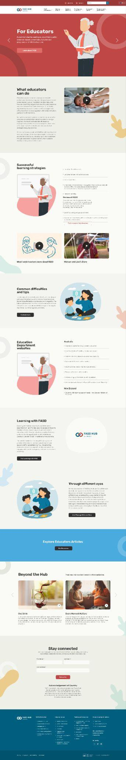

**Create a New Page**

First, we have to create a page. To do so, go to the **Admin** **dashboard**, and then click on the "**Pages**" menu from the left sidebar.

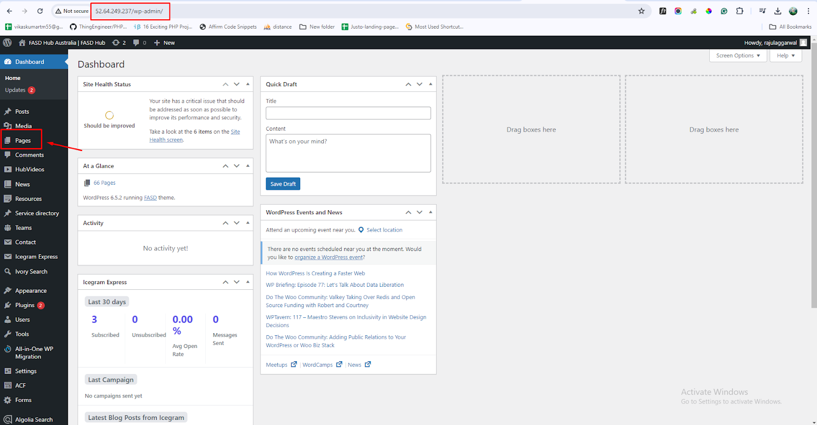

After that, you need to click on "**Add New Page**" to create a new page, as shown in the screenshot below.

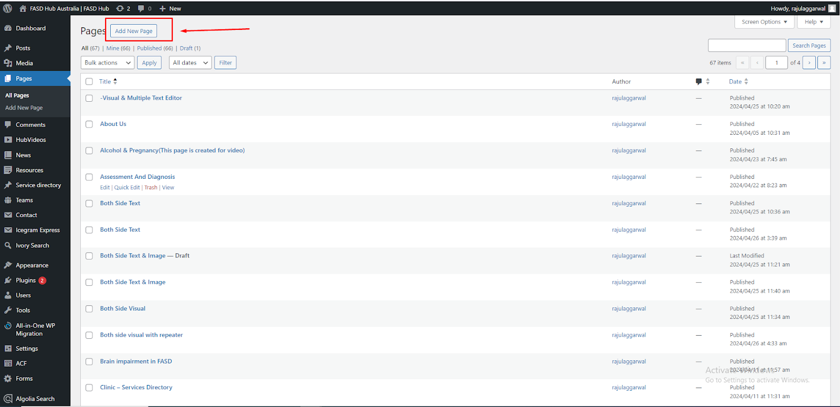

Now you need to enter the **Title of the page**, and then click on “**Publish**”. Your page has been published now, as shown in the screenshot below.

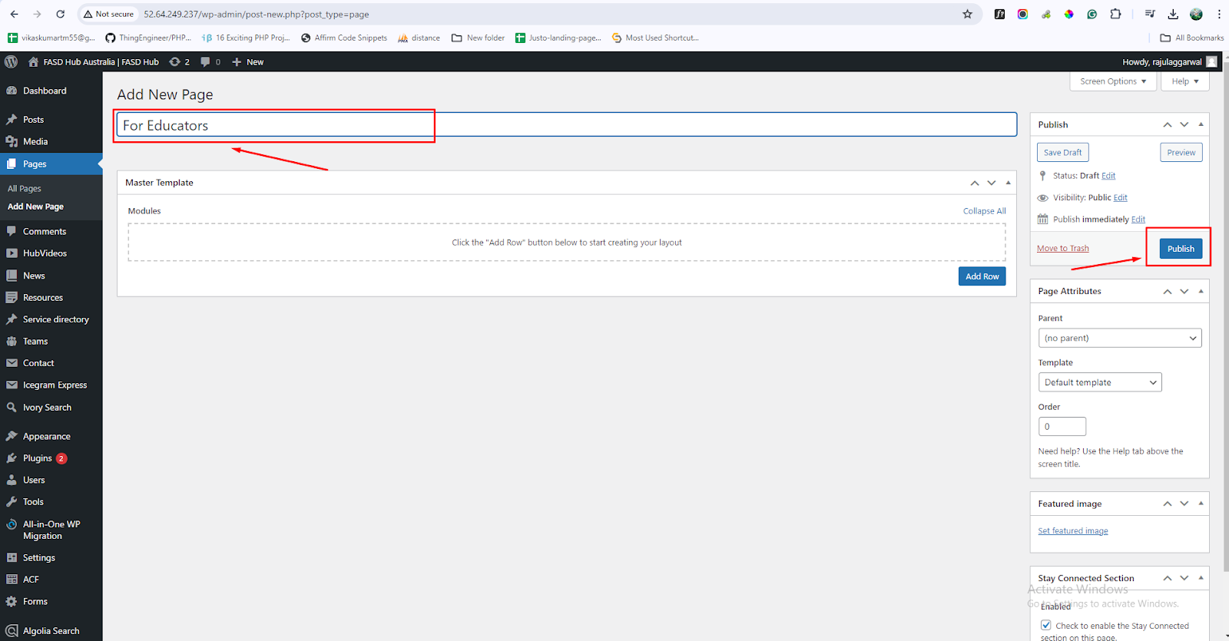

After that, we will begin adding the **ACF layout** inside this page, for which you need to click on "**Add Row**," and multiple layouts will be shown here, as shown in the screenshot below.

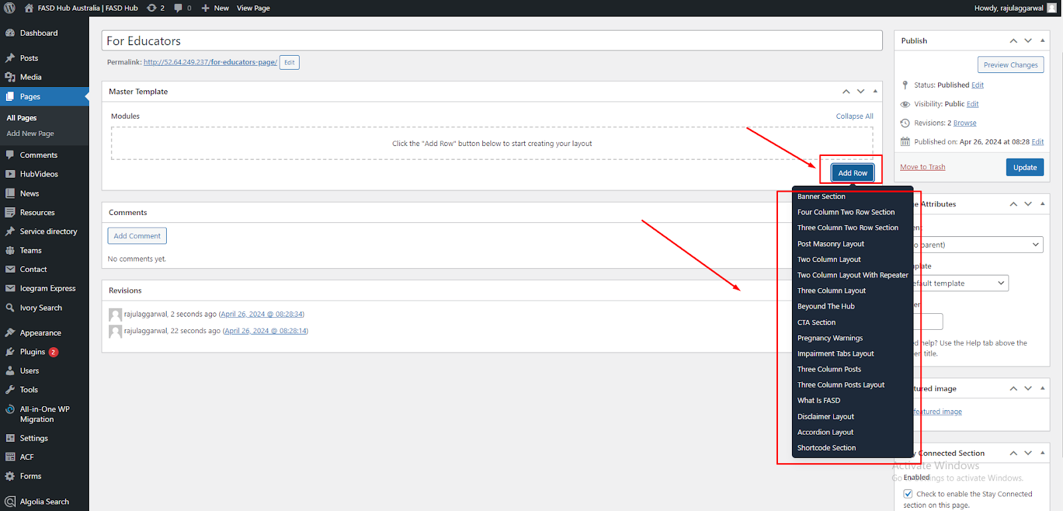

**Banner Section**

Our first layout will be a **Banner Section**, and a preview of this section is attached below.

**Preview (Banner with slider)**



**Steps below:**

For this, you have to choose the banner section by clicking on "**Banner Section**" from the dropdown menu, as shown in the screenshot below.

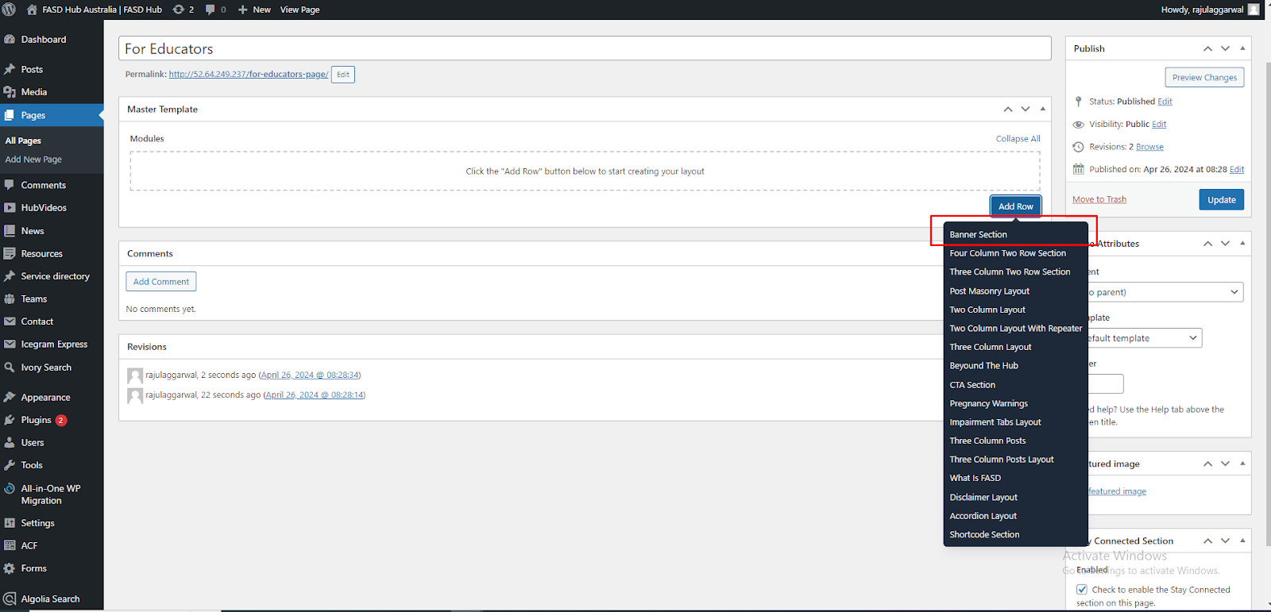

After that, the module related to the **banner section** will be added, and you will find options related to the **banner section**, as shown in the screenshot below.

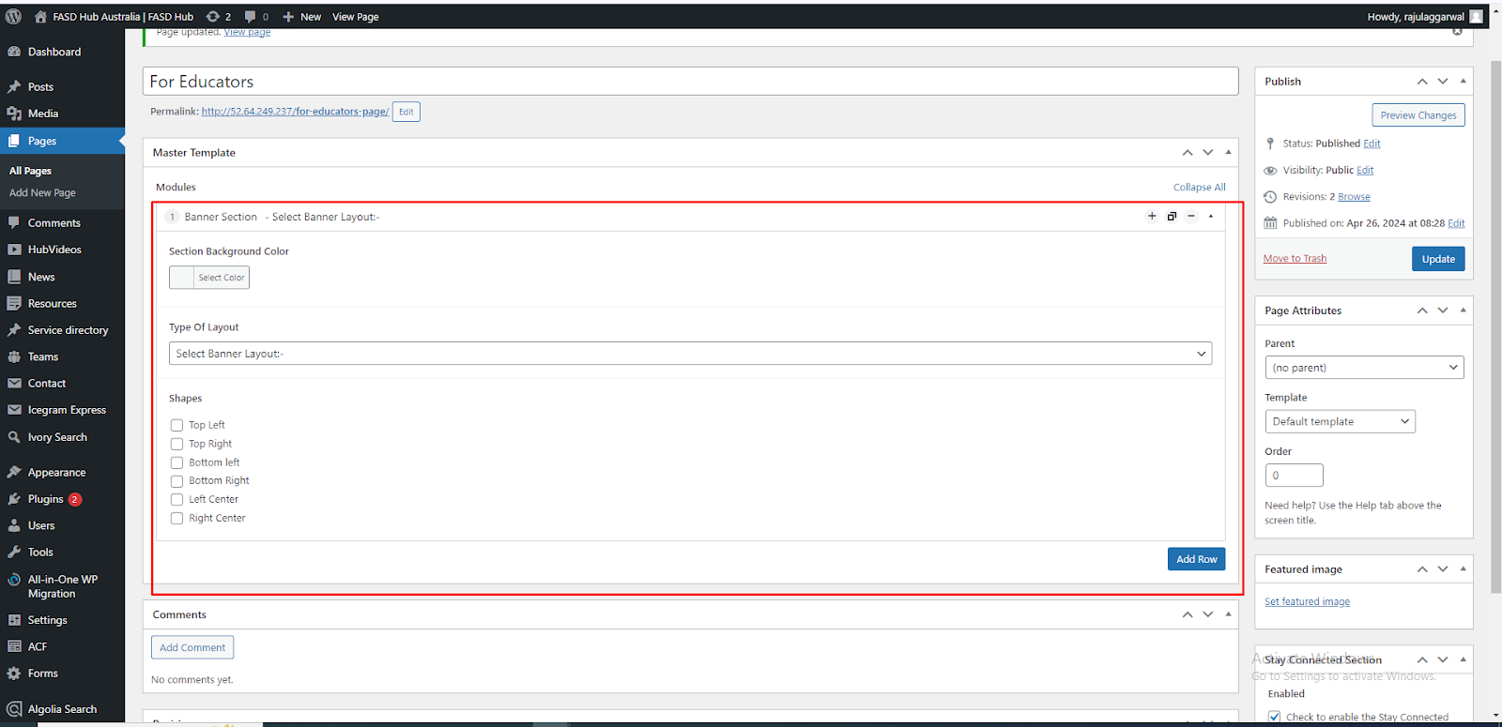

Now you will see the option for **Section Background Color**. From here, you can change the background color of the section, as shown in the screenshot below

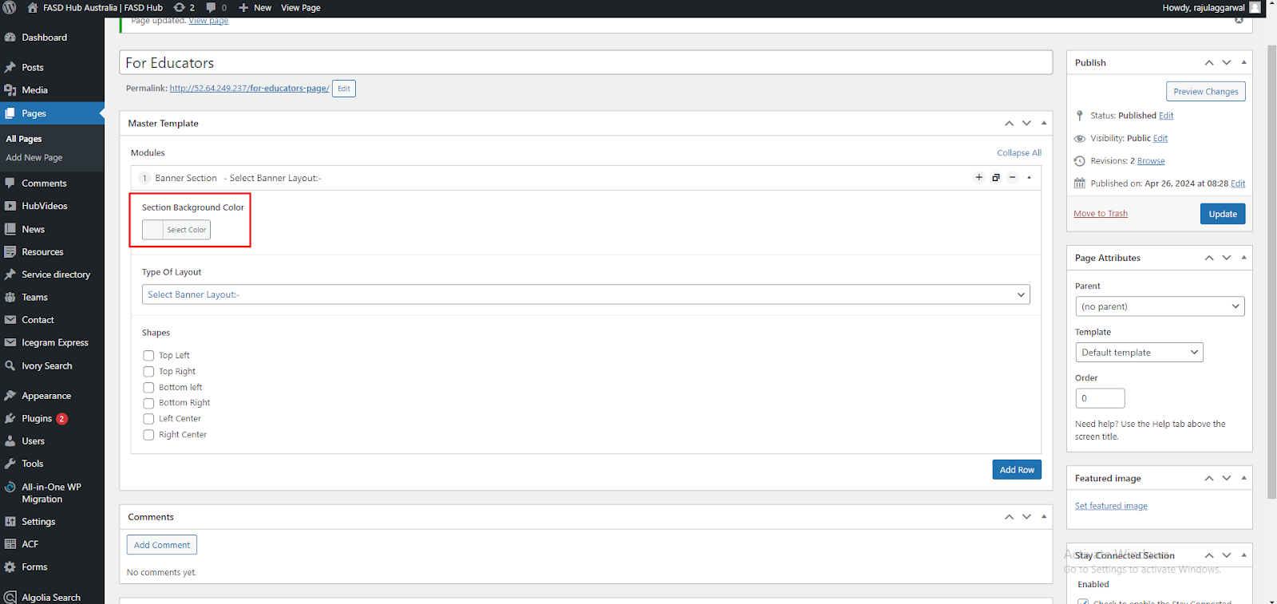

Now, you will see the option for **Type Of Layout**. From here, Select the **'Banner with Slider'** option from the dropdown, as shown in the screenshot below.

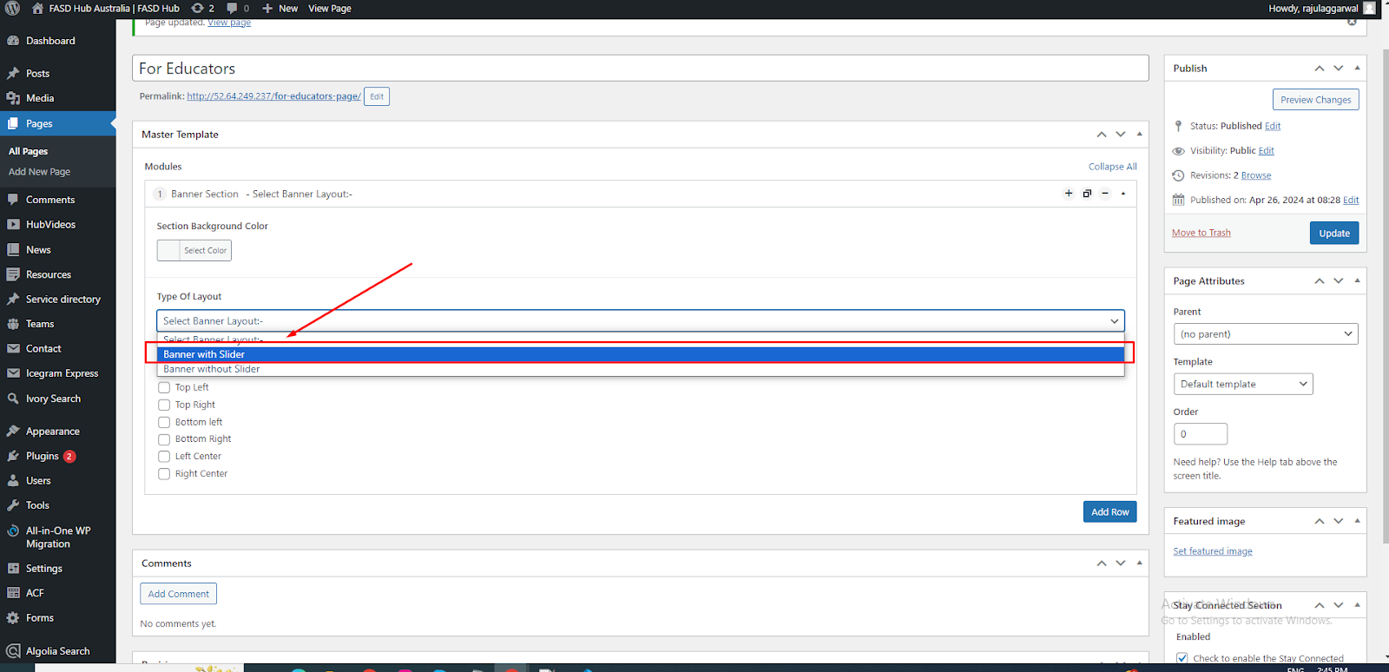

We have selected the **Banner with a Slider** layout, in which we need to insert content according to the slides, as shown in the screenshot below.

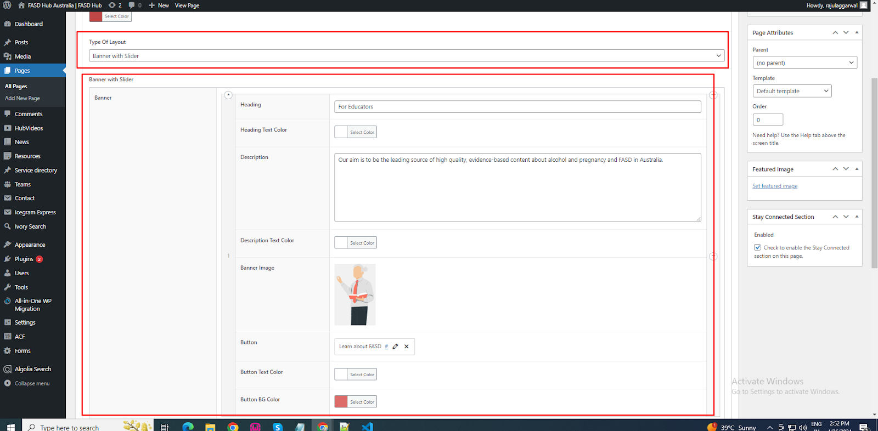

If you want to add more slides, click on the '**Add Row**' button as shown in the screenshot below.

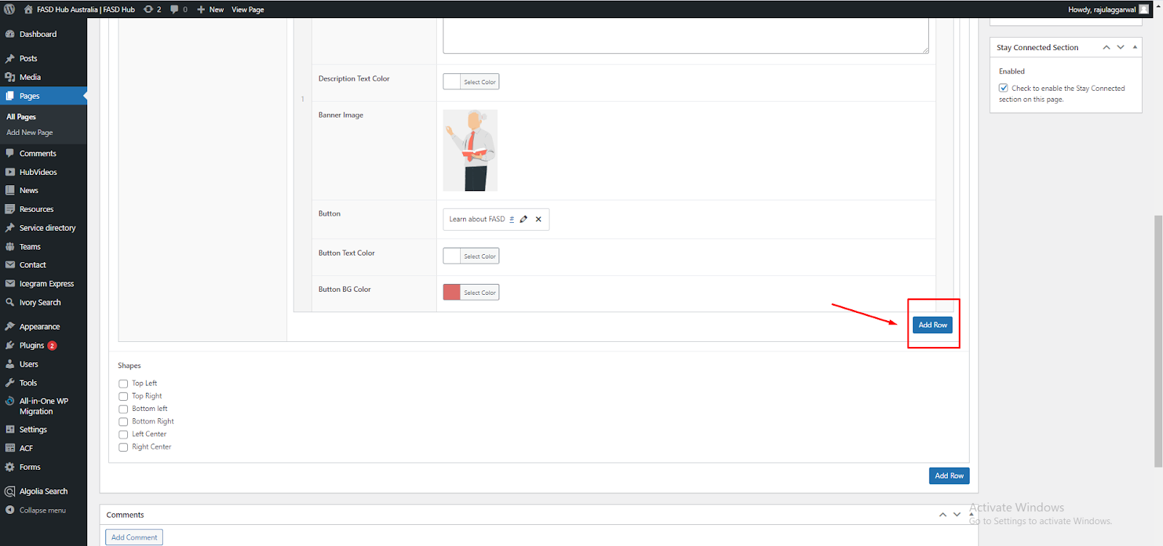

Now, add content for slide 2. If you want to add more slides, you can click on the **'Add Row'** button to include additional slides, as shown in the screenshot below.

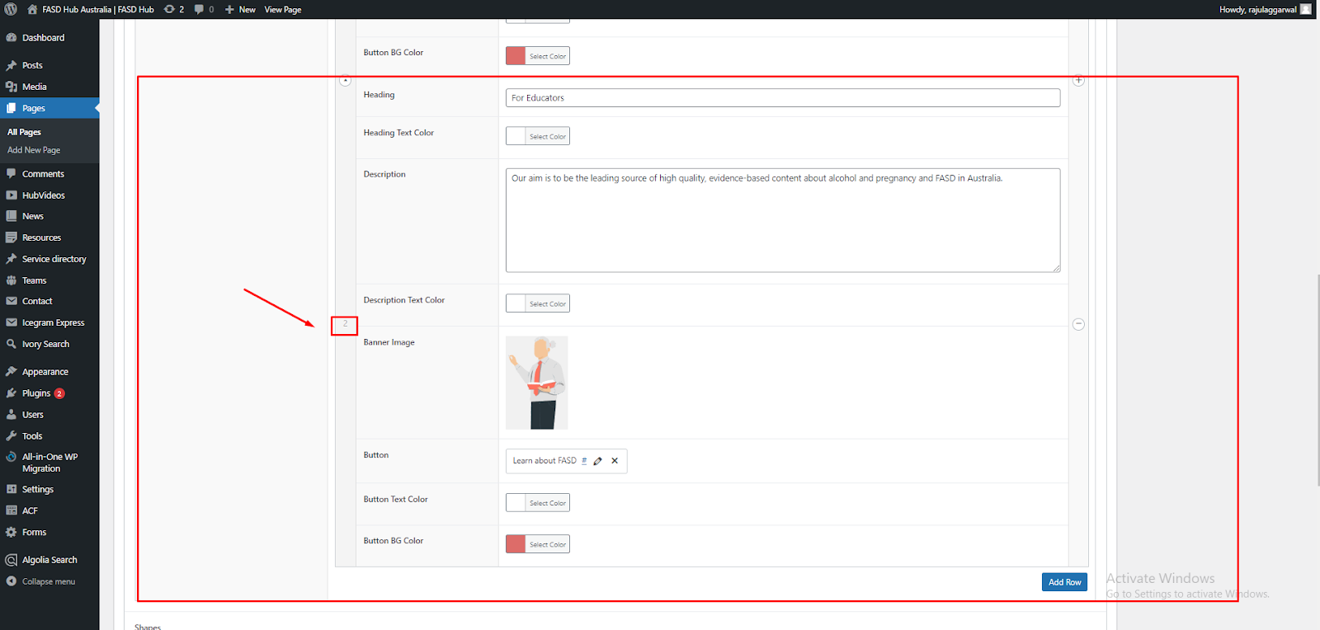

**—To add shapes to any section**

To add shapes to any section, you will see the option to **add shapes**, where you can add images of shapes in six different positions as you desire, as shown in the screenshot below.

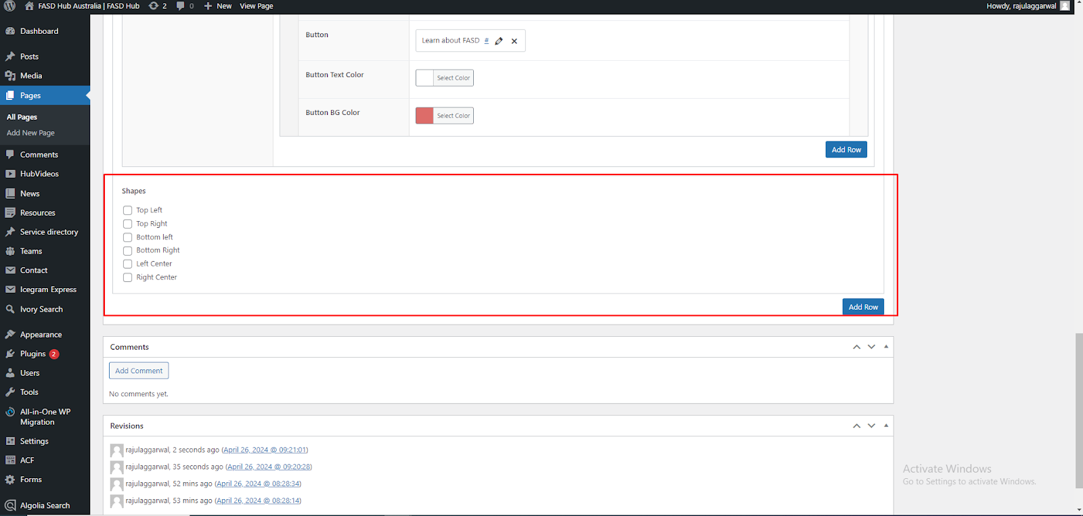

You need to select the checkbox according to the position where you want to add the image, then you will see the option to add the image, as shown in the screenshot below.

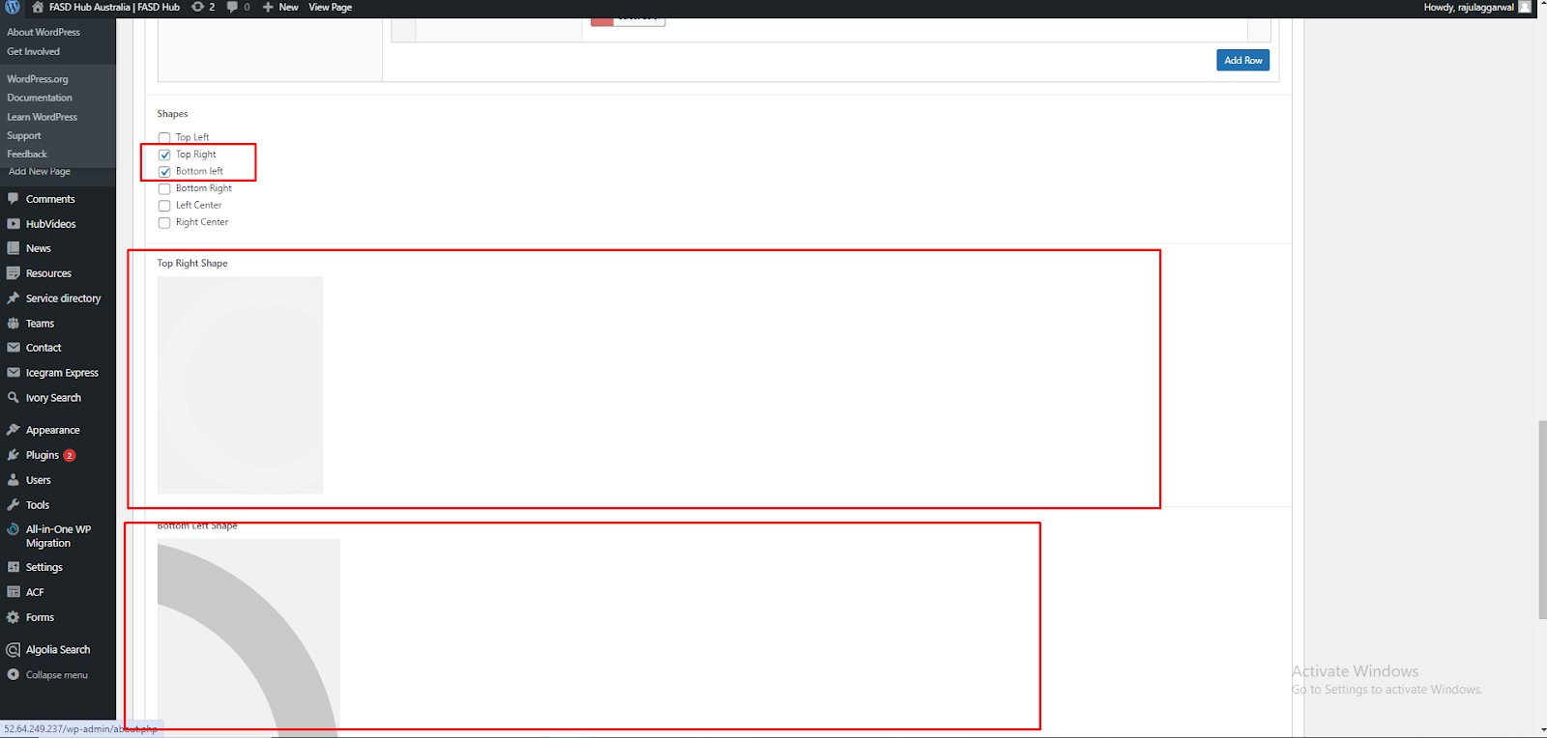

After adding content to these field boxes, save your changes by clicking on the “**Update**” button and check your page, as shown in the screenshot below.

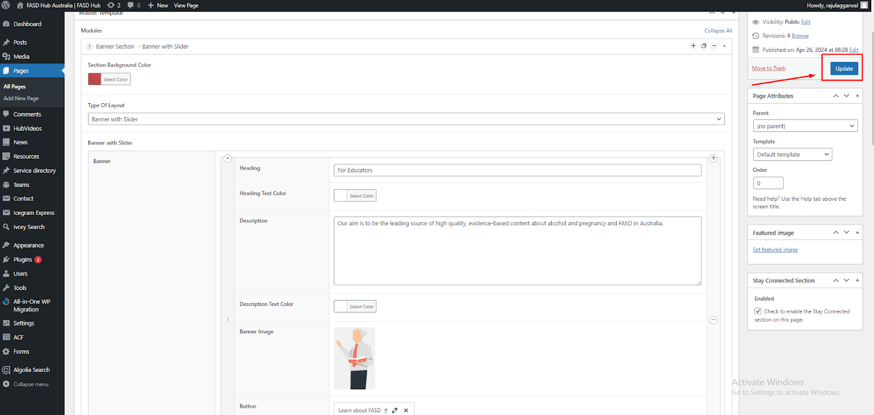

Finally, we have achieved the output of the **banner section** on the front end, as shown in the screenshot below.

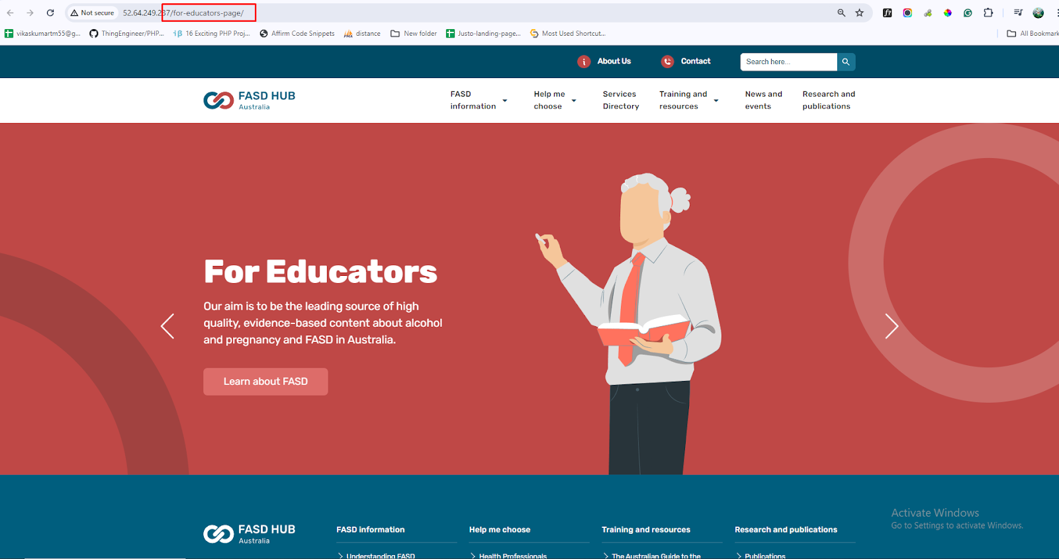

**Two Column Layout**

**—Visual Duo & Text Editor**

After the banner section, you have to add a **Two column layout section,** and a preview of this section is attached below

**Preview (Two Column Layout section - Visual Duo & Text Editor)**

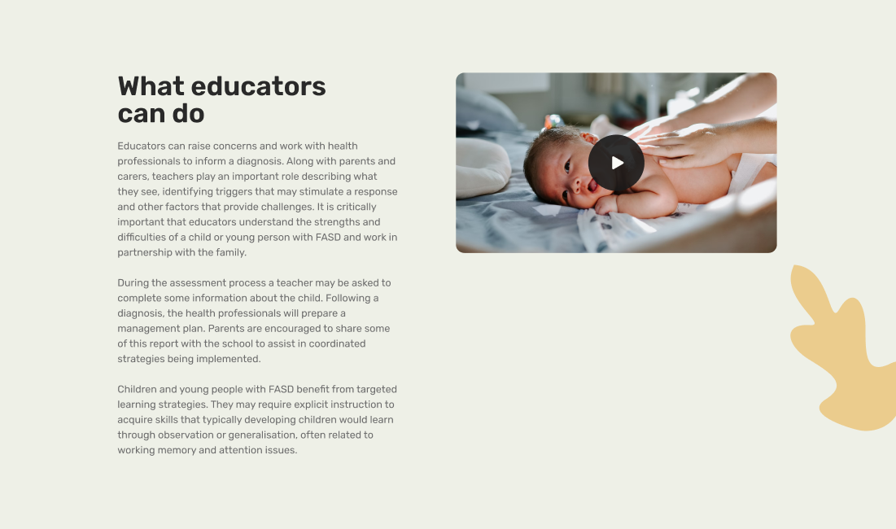

**Steps below:**

First, click on **'Add row**,' then select **Two Column Layout** from the dropdown menu, as shown in the screenshot below.

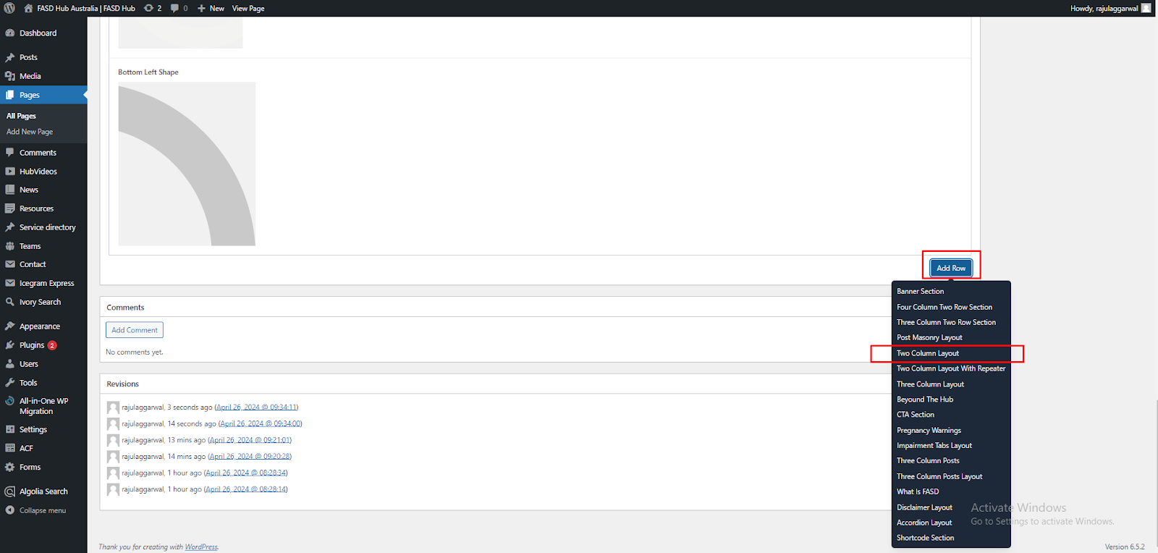

After this, you have to select the '**Visual Duo & Text Editor**' option from the **Type of Layout** dropdown, as shown in the screenshot below.

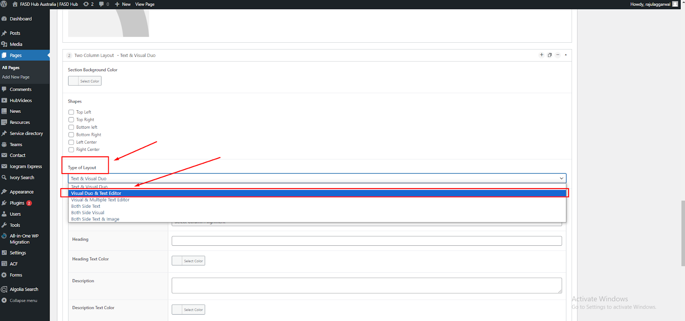

You will now see field boxes here. You need to insert data such as **background images**, **shapes**, and **content** according to the fields, as shown in the screenshot below.

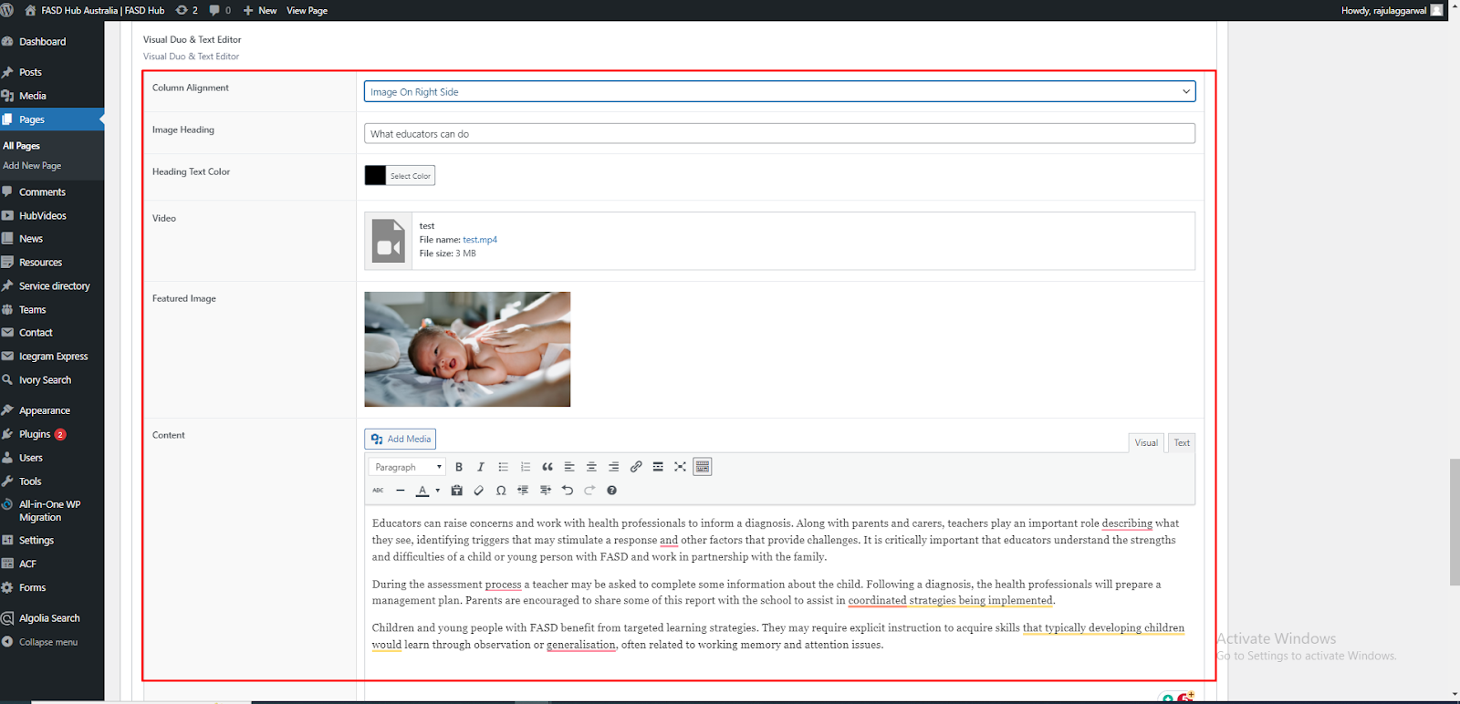

Here, you will have two options: one for **video** and the other for **image**. You can create two types of layouts using these options: '**Image with Text**' and **'Video with Text**'. If you choose to add a **video**, you will see the option for the **featured image**, where you need to set the **thumbnail**, as shown in the screenshot below.

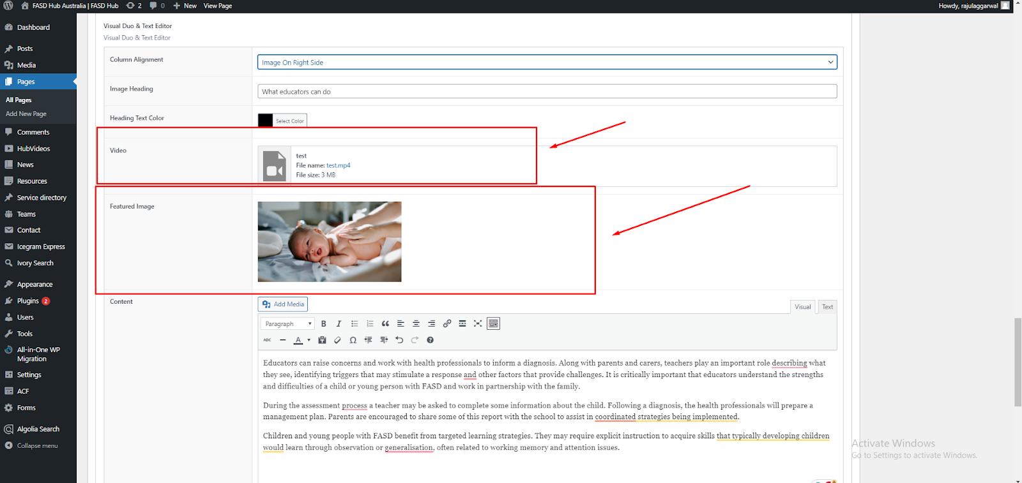

After adding content to these field boxes, save your changes and check your page, as shown in the screenshot below.

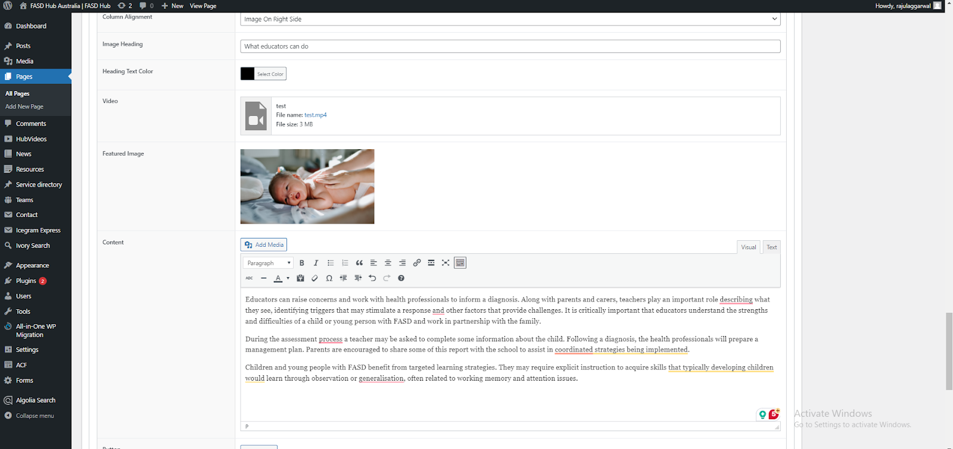

Finally, we have achieved the desired output of the **Two Column Layout** for the **Visual Duo & Text Editor** section on the front end with the **video** on the right side, as shown in the screenshot below.

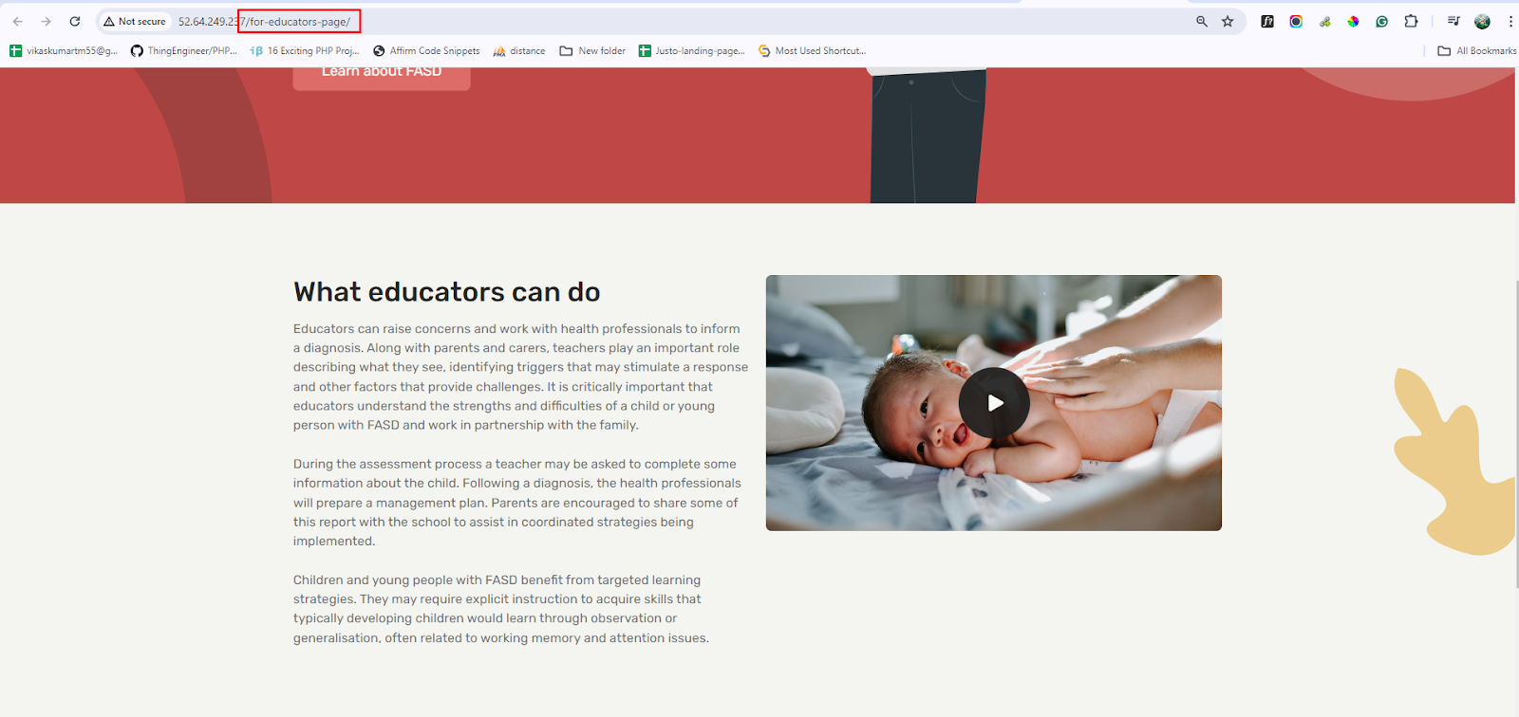

**—Both Side Text**

After this, you have to add the **Two Column Layout** section again. A preview of this section is attached below.

**Preview (Two Column Layout section - Both Side Text)**

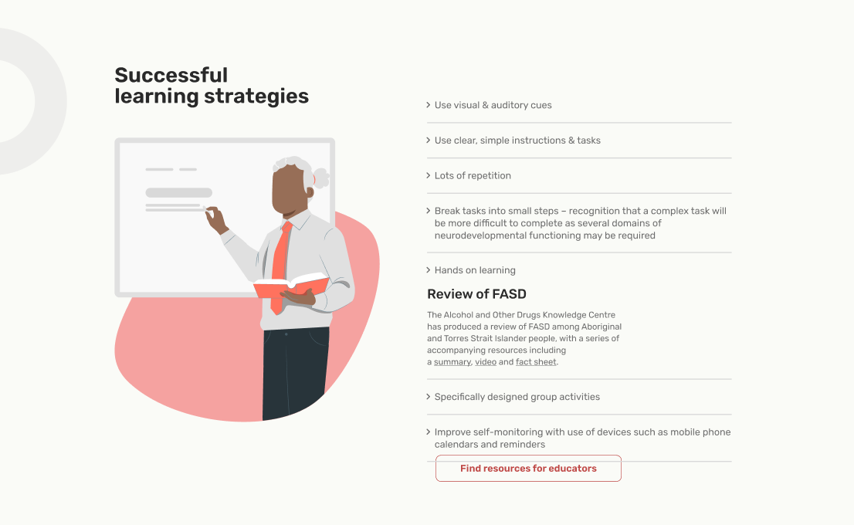

**Steps below:**

Now, repeat the previous steps: click on '**Add Row**' and then select '**Two Column Layout**' from the dropdown menu, as shown in the screenshot below.

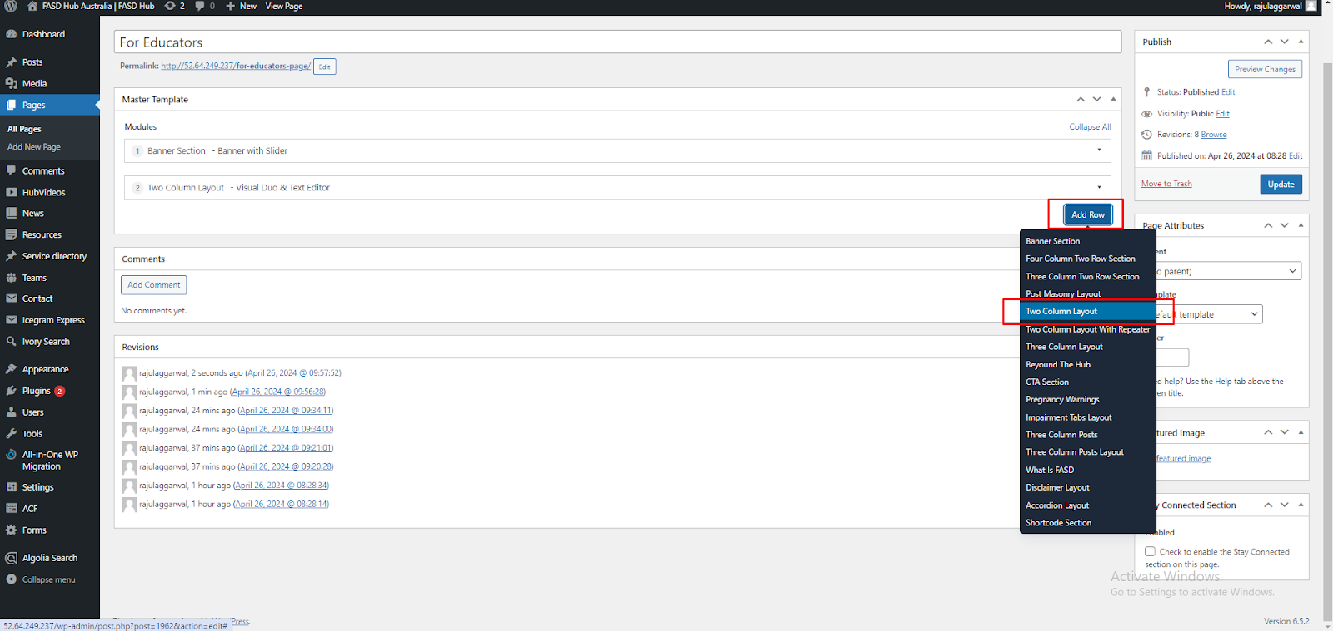

This time, you need to select the '**Both Side Text**' option from the **Type of Layout** dropdown, as shown in the screenshot below.

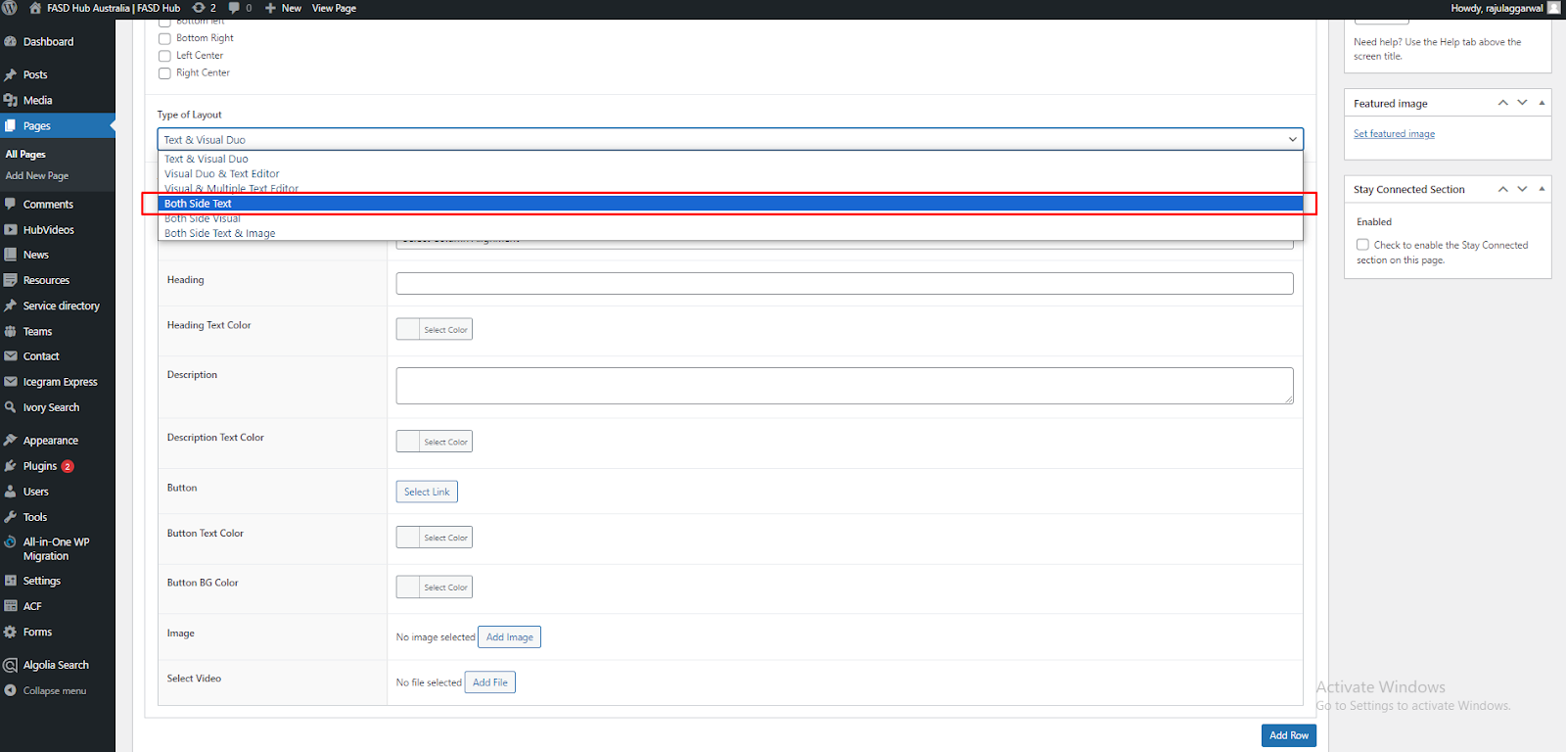

You will now see field boxes here. You need to insert data such as **background images**, **shapes**, and **content** according to the fields, as shown in the screenshot below.

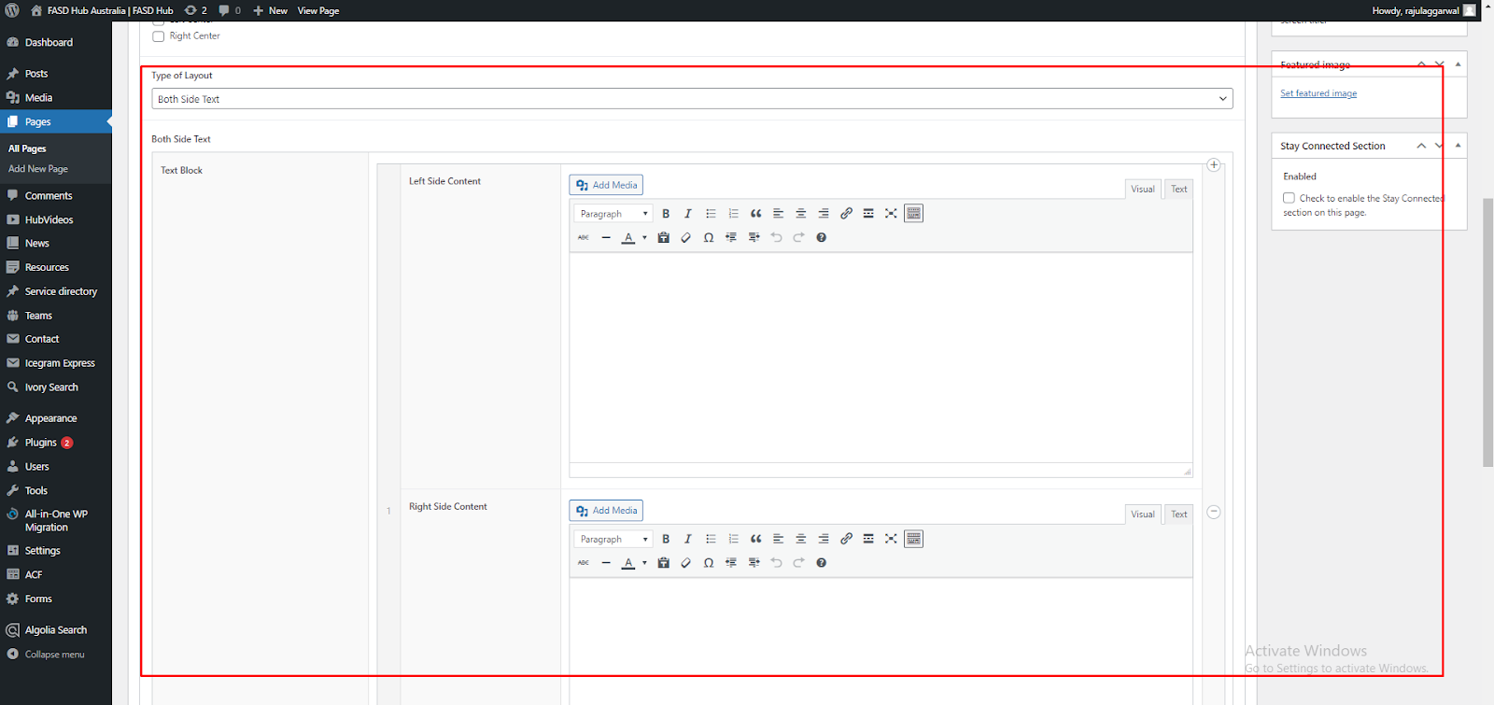

After adding content to both side field boxes, save your changes and check your page, as shown in the screenshot below.

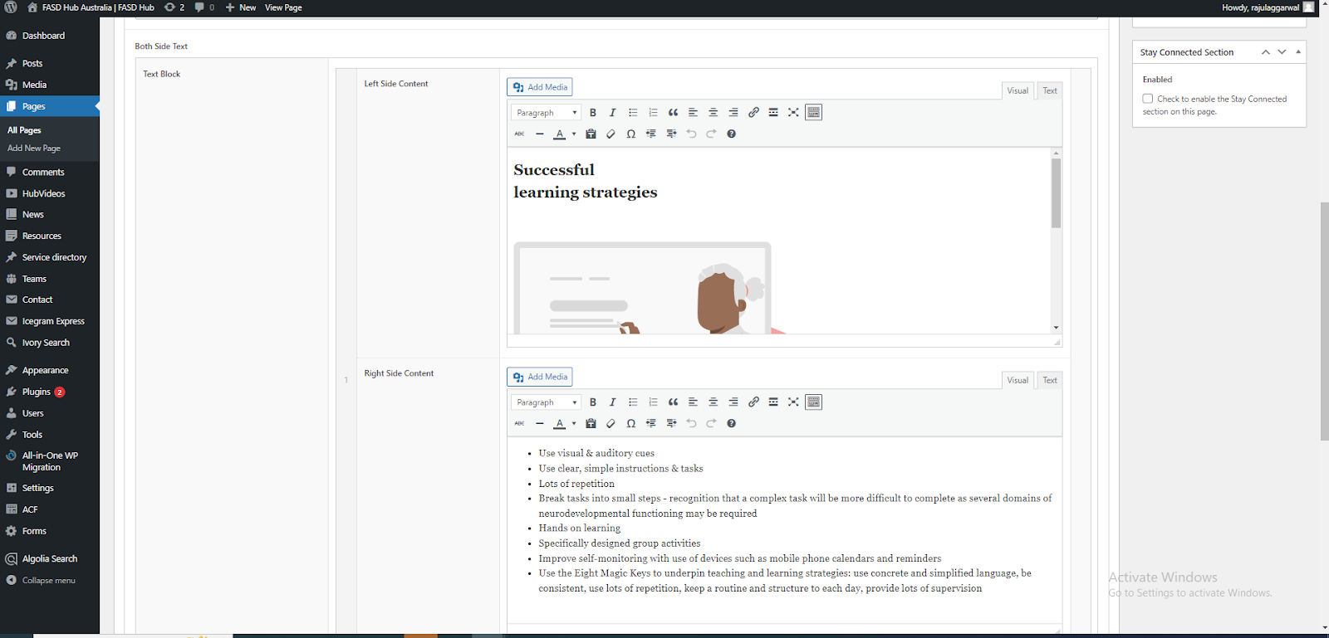

Finally, we have achieved the desired output of the **two-column layout** for the **Both Side Text** section on the front end, as shown in the screenshot below.

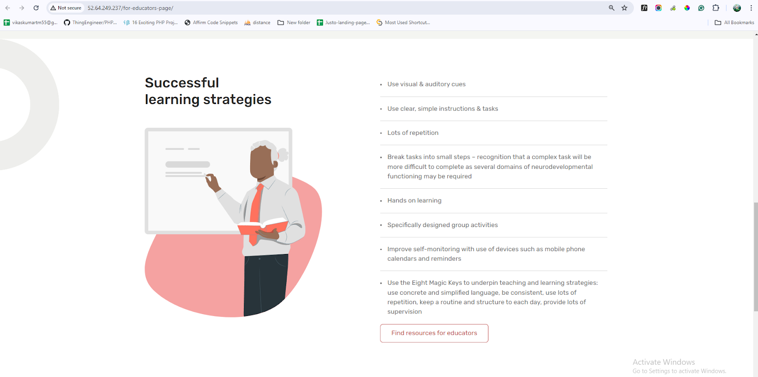

**—Both Side Visuals**

After this, you have to add the Two Column Layout section again. A preview of this section is attached below.

**Preview (Two Column Layout section - Both Side Visuals)**

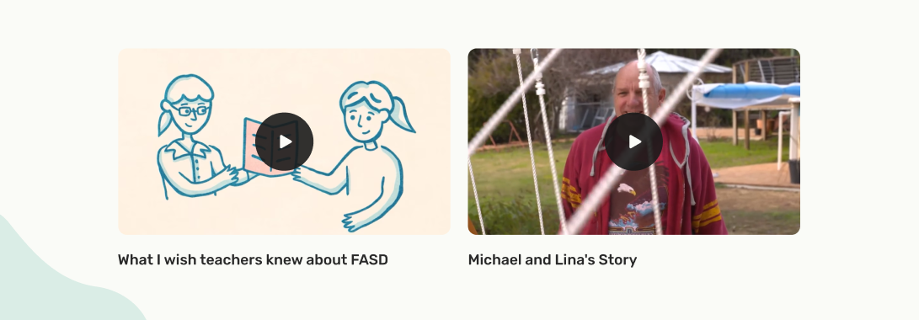

**Steps below:**

Now, repeat the previous steps: click on '**Add Row**' and then select '**Two Column Layout**' from the dropdown menu, as shown in the screenshot below.

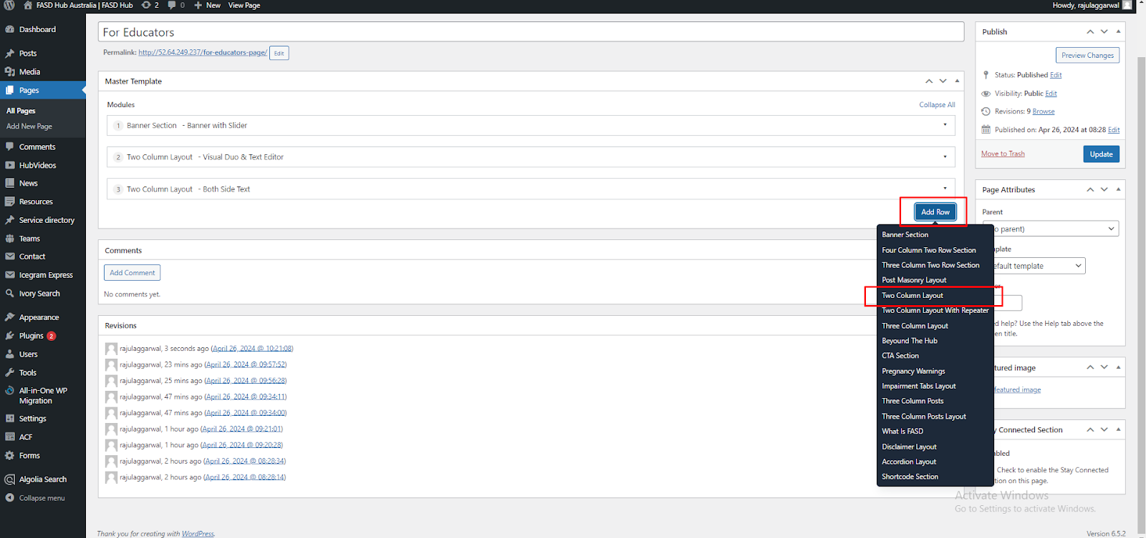

This time, you need to select the '**Both Side Visuals**' option from the **Type of Layout** dropdown, as shown in the screenshot below.

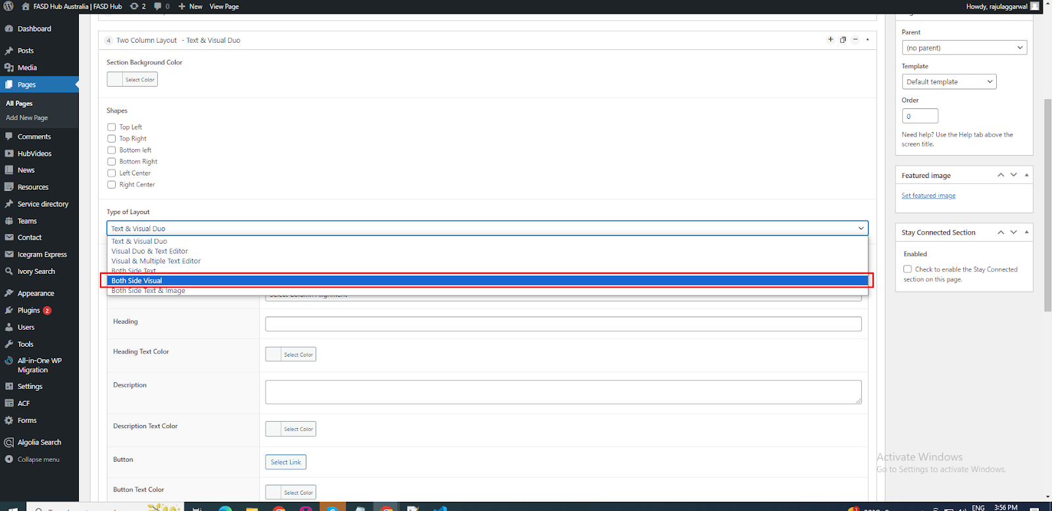

Here, you will have two options: one for **video** and the other for **image** on both sides. You can create two types of layouts using these options: '**Image with Text**' and **'Video with Text**'. If you choose to add a **video**, you will see the option for the **featured image**, where you need to set the **thumbnail**, as shown in the screenshot below.

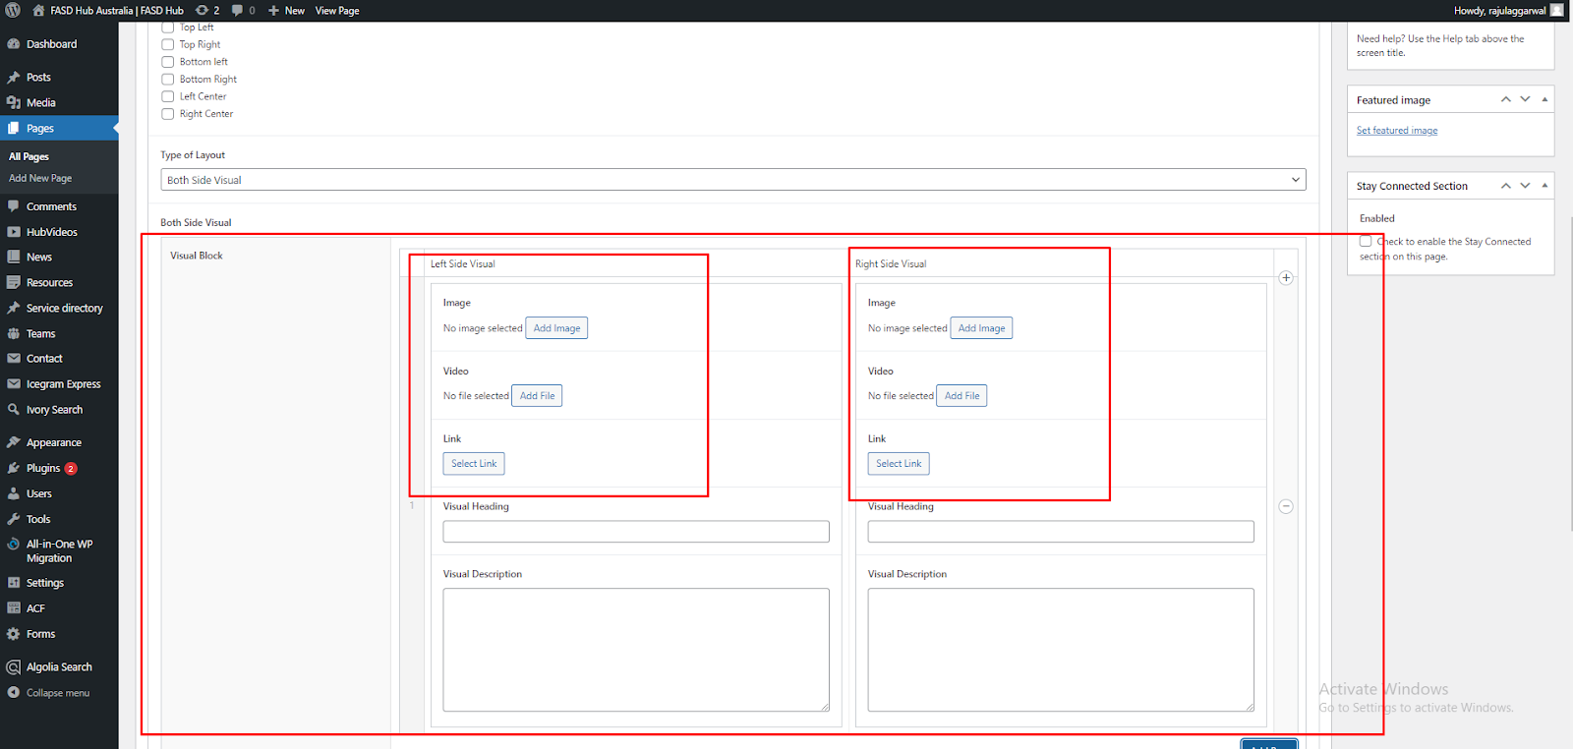

After adding content to these field boxes, save your changes and check your page, as shown in the screenshot below.

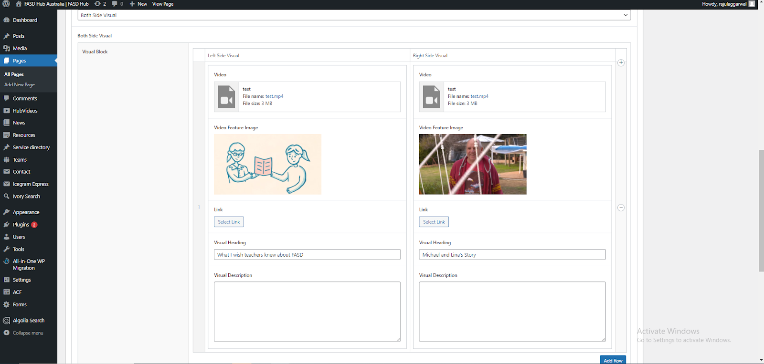

Finally, we have achieved the desired output of the **two-column layout** for the **Both Side Visuals** section on the front end, as shown in the screenshot below.

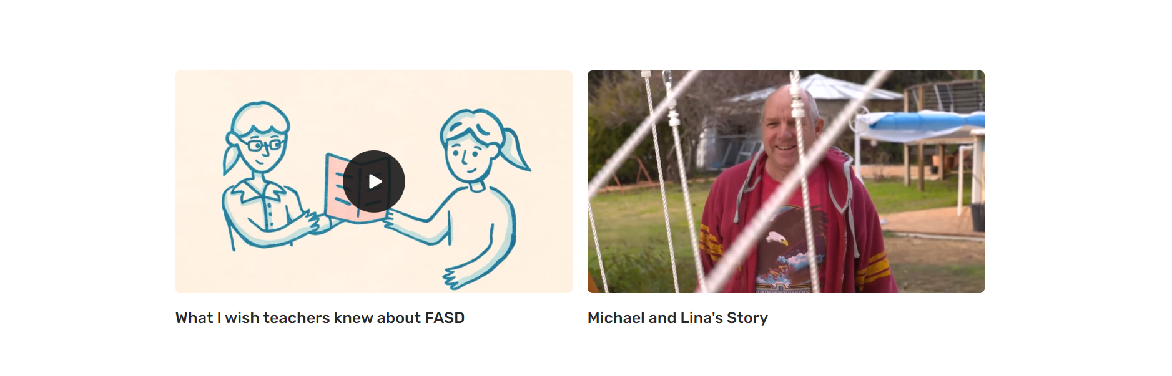

**—Text & Visual Duo**

After this, you have to add the Two Column Layout section again. A preview of this section is attached below.

**Preview (Two Column Layout section - Text & Visual Duo)**

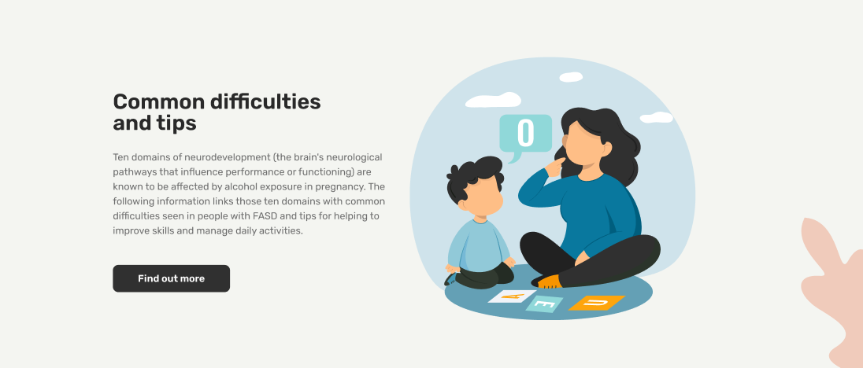

**Steps below:**

Now, repeat the previous steps: click on '**Add Row**' and then select '**Two Column Layout**' from the dropdown menu, as shown in the screenshot below.



This time, you need to select the '**Text & Visual Duo**' option from the **Type of Layout** dropdown, as shown in the screenshot below.

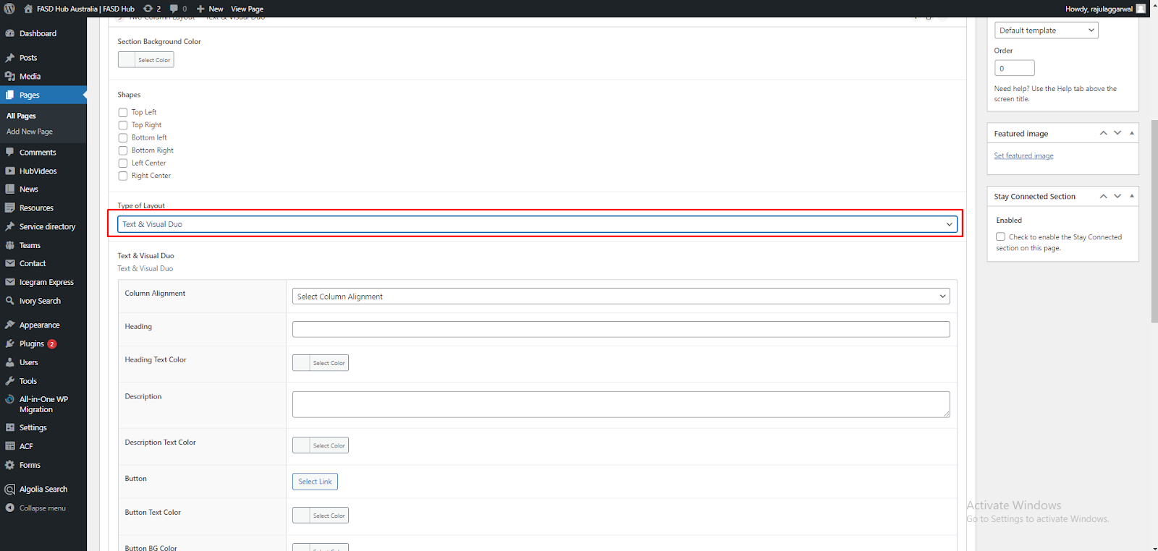

Now, You will see field boxes here. You need to insert data such as **background images**, **shapes**, and **content** according to the fields, as shown in the screenshot below.

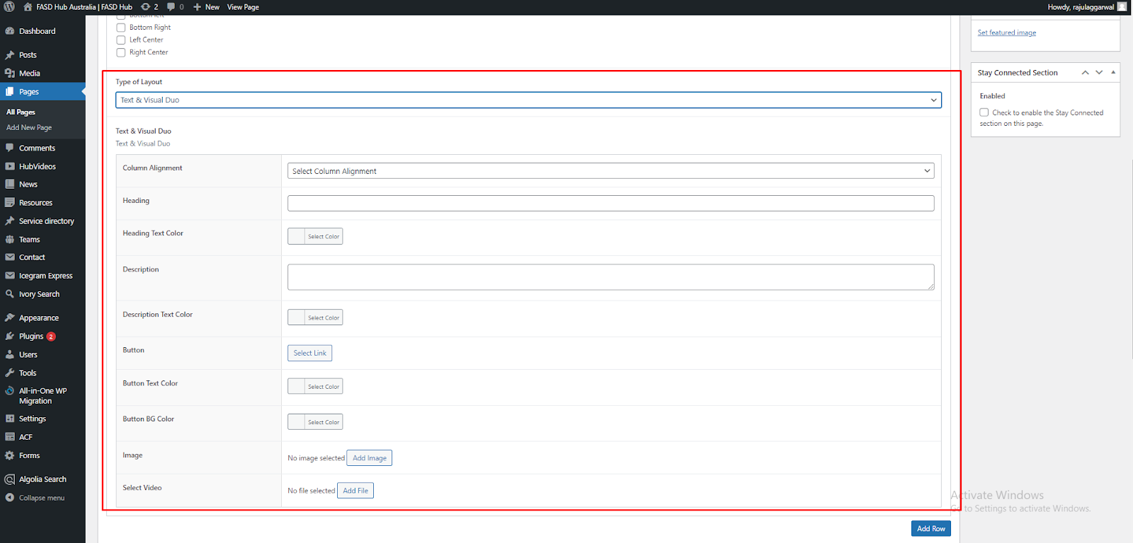

After adding content to these field boxes, save your changes and check your page, as shown in the screenshot below.  
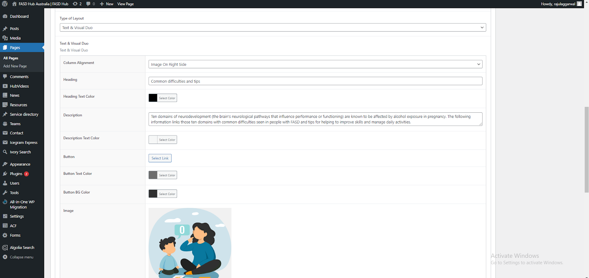

Finally, we have achieved the desired output of the **two-column layout** for the **Text & Visual Duo** section on the front end, as shown in the screenshot below.

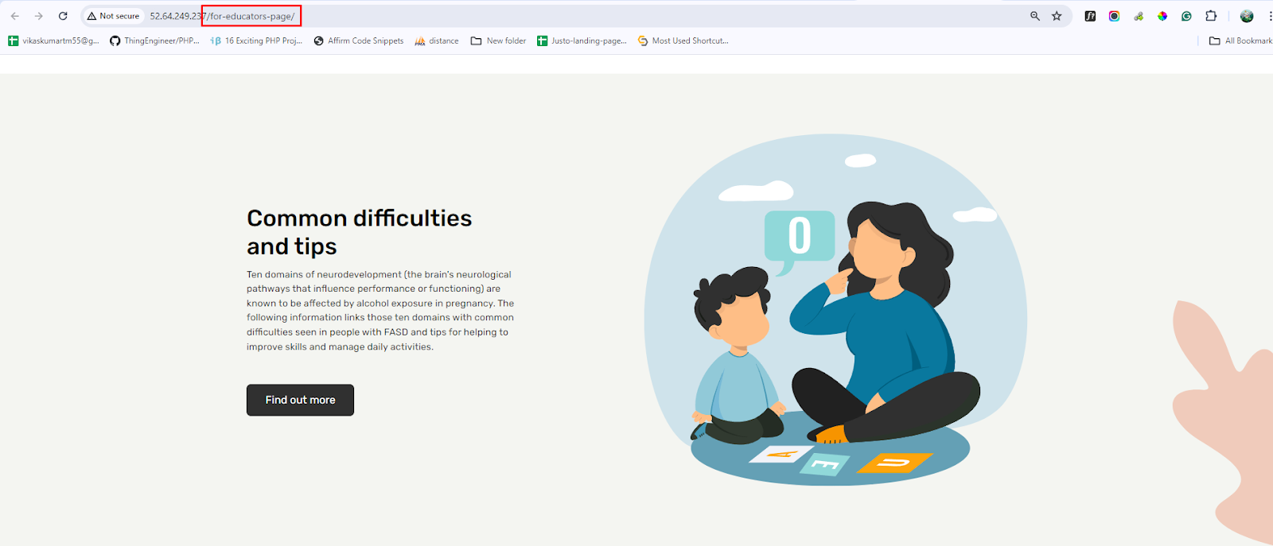

**—Both Side Text**

After this, you have to add the **Two Column Layout** section again. A preview of this section is attached below.

**Preview (Two Column Layout section - Both Side Text)**



**Steps below:**

Now, repeat the previous steps: click on '**Add Row**' and then select '**Two Column Layout**' from the dropdown menu, as shown in the screenshot below.

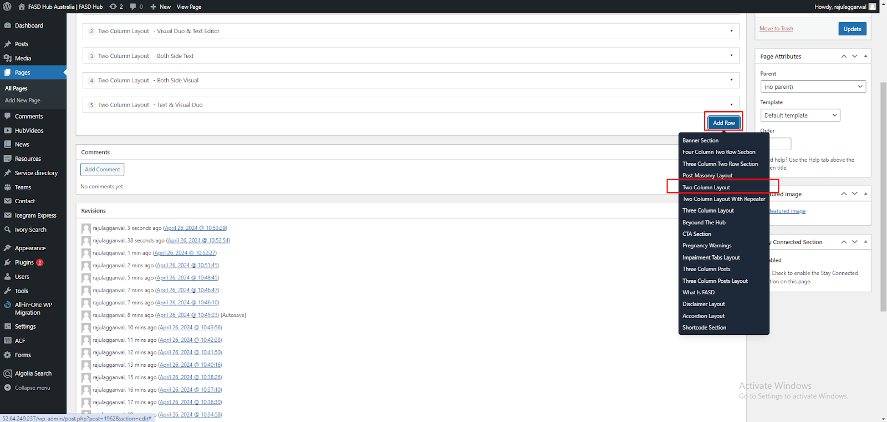

This time, you need to select the '**Both Side Text**' option from the **Type of Layout** dropdown, as shown in the screenshot below.



You will now see field boxes here. You need to insert data such as **background images**, **shapes**, and **content** according to the fields, as shown in the screenshot below.

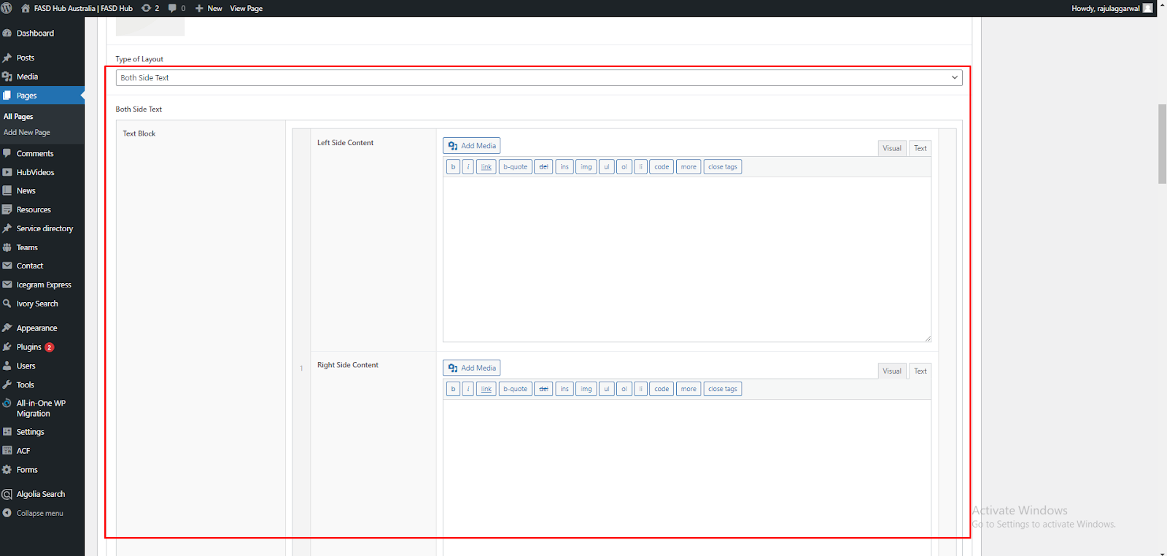

After adding content to these field boxes, save your changes and check your page, as shown in the screenshot below.   
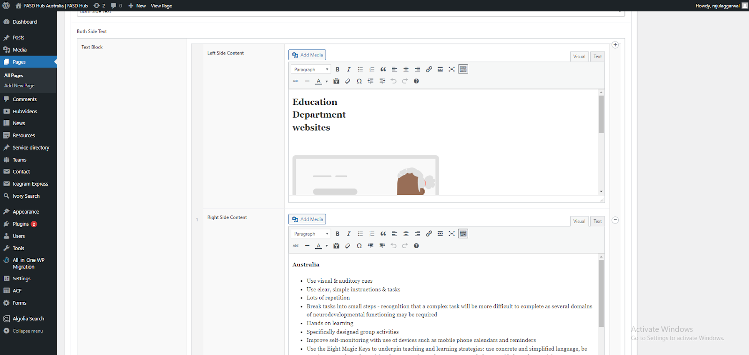

Finally, we have achieved the desired output of the **two-column layout** for the **Both Side Text** section on the front end, as shown in the screenshot below.

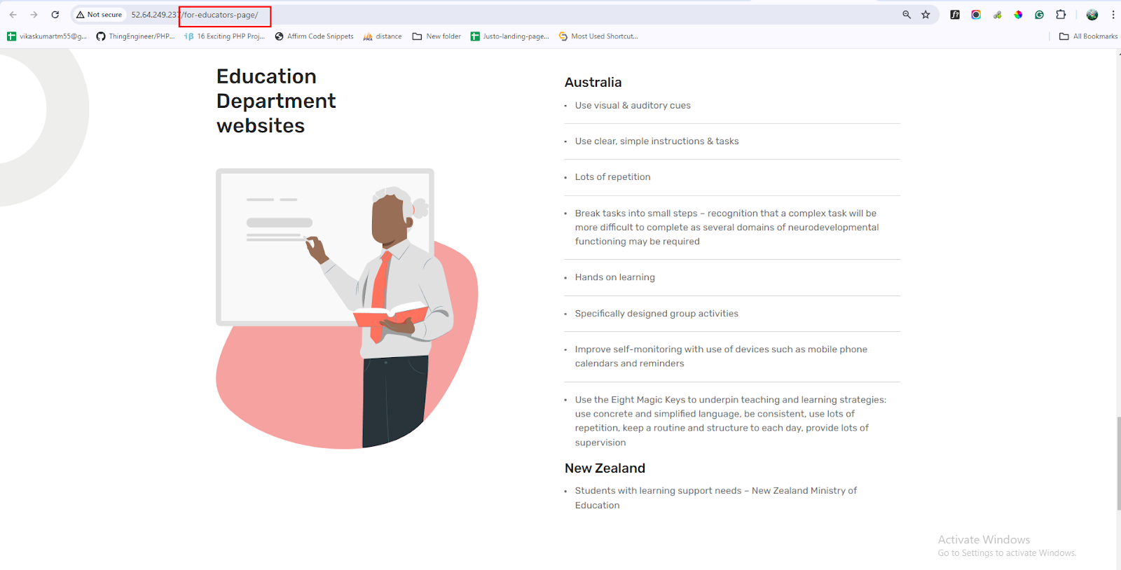

**Two-Column Layout With Repeater**

**—Text & Visual Duo**

After this, you have to add the **Two Column Layout With Repeater** section. A preview of this section is attached below.

**Preview (Two Column Layout section - Text & Visual Duo)**

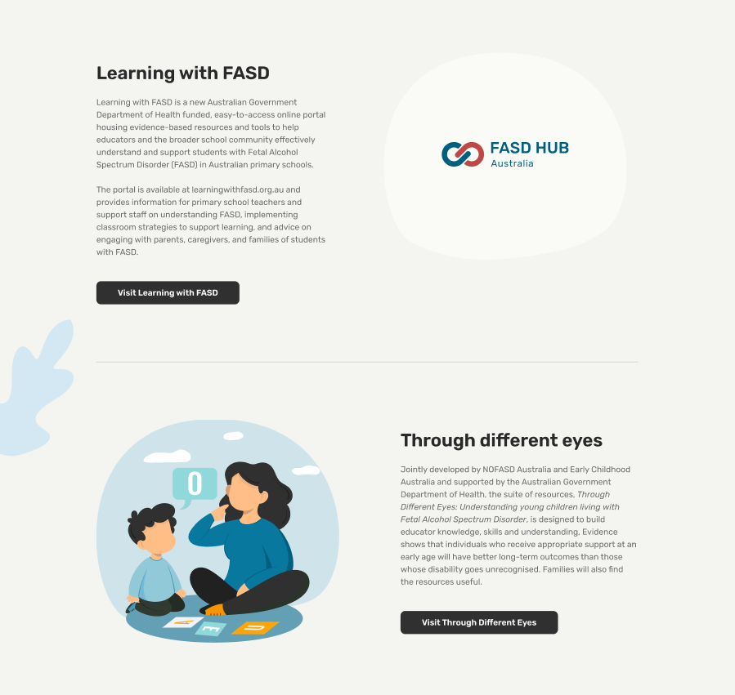

**Steps below:**

First, click on **'Add row**,' then select **Two Column Layout with Repeater** from the dropdown menu, as shown in the screenshot below.

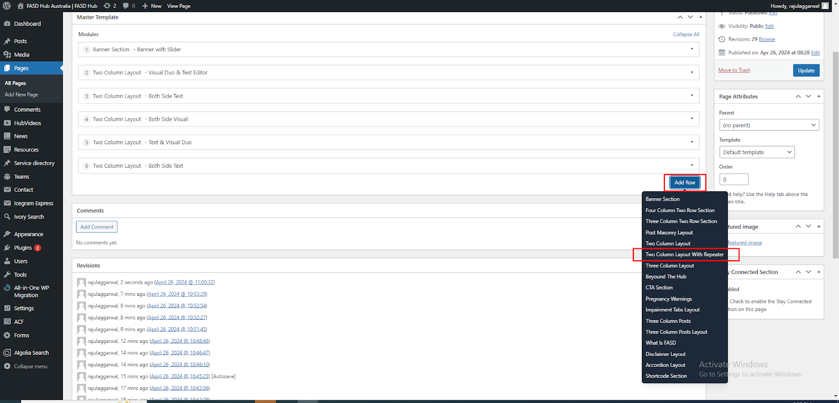

After this, you have to select the '**Text & Visual Duo**' option from the **Type of Layout** dropdown, as shown in the screenshot below.

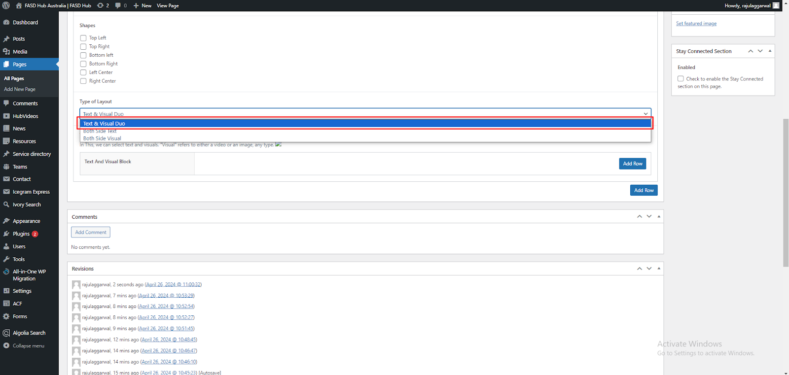

After that, click on the **'Add row'** button and add **Text And Visual blocks** for adding content, as shown in the screenshot below.

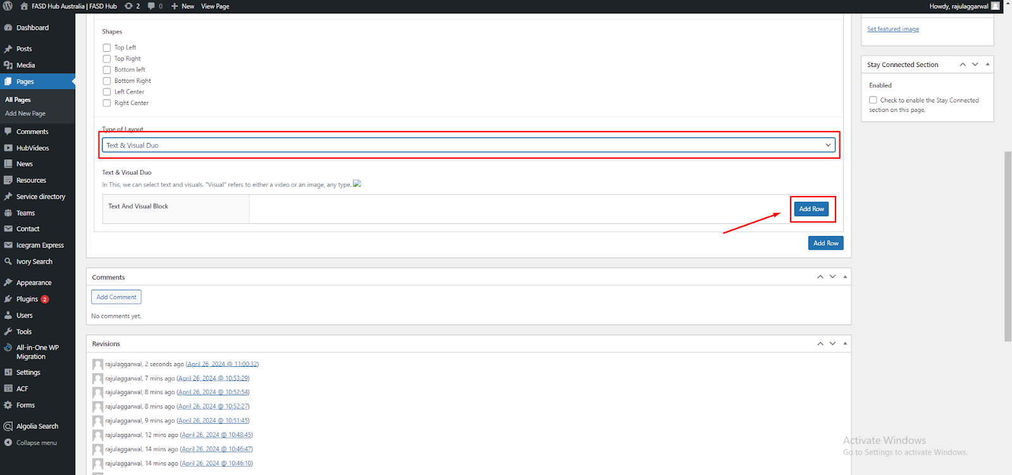

Here, you will have two options: one for **video** and the other for **image**. You can create two types of layouts using these options: '**Image with Text**' and **'Video with Text**'. If you choose to add a **video**, you will see the option for the **featured image**, where you need to set the **thumbnail**, as shown in the screenshot below.

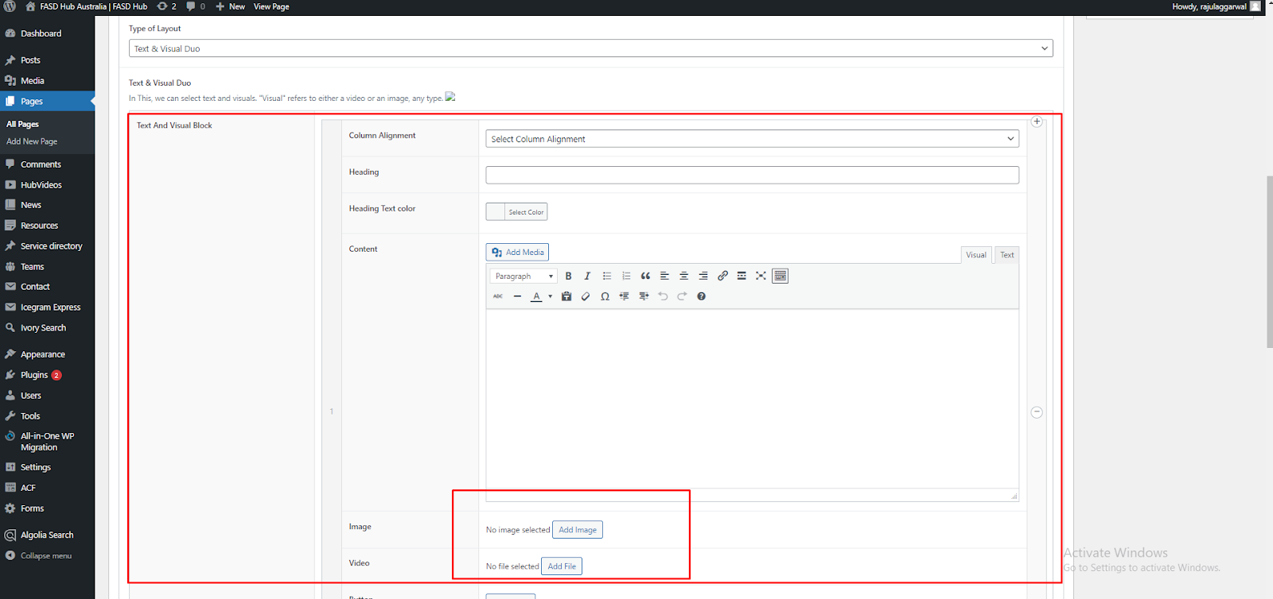

If you want to add this **Text and Visual Block** repeatedly, you can do so by clicking the **'Add row'** button.

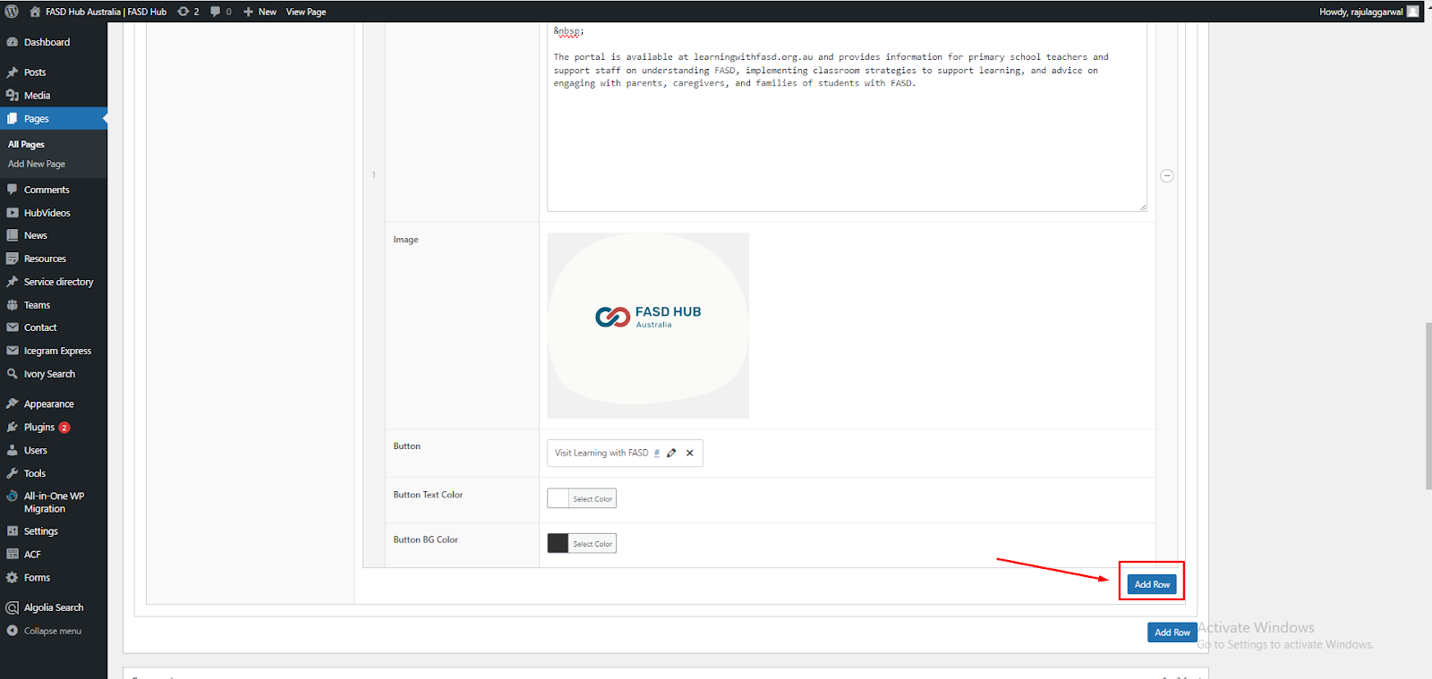

After adding content to these field boxes, save your changes and check your page, as shown in the screenshot below.

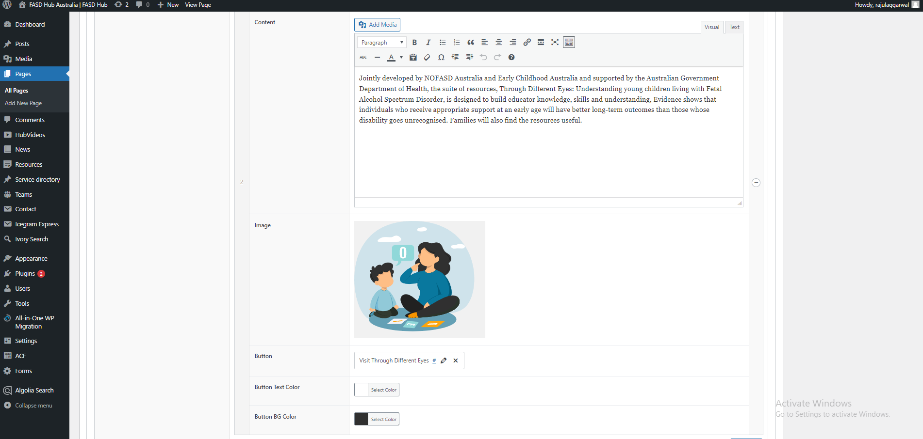

Finally, we have achieved the desired output of the **Two Column Layout With Repeater** for the **Text & Visual Duo** section on the front end, as shown in the screenshot below.

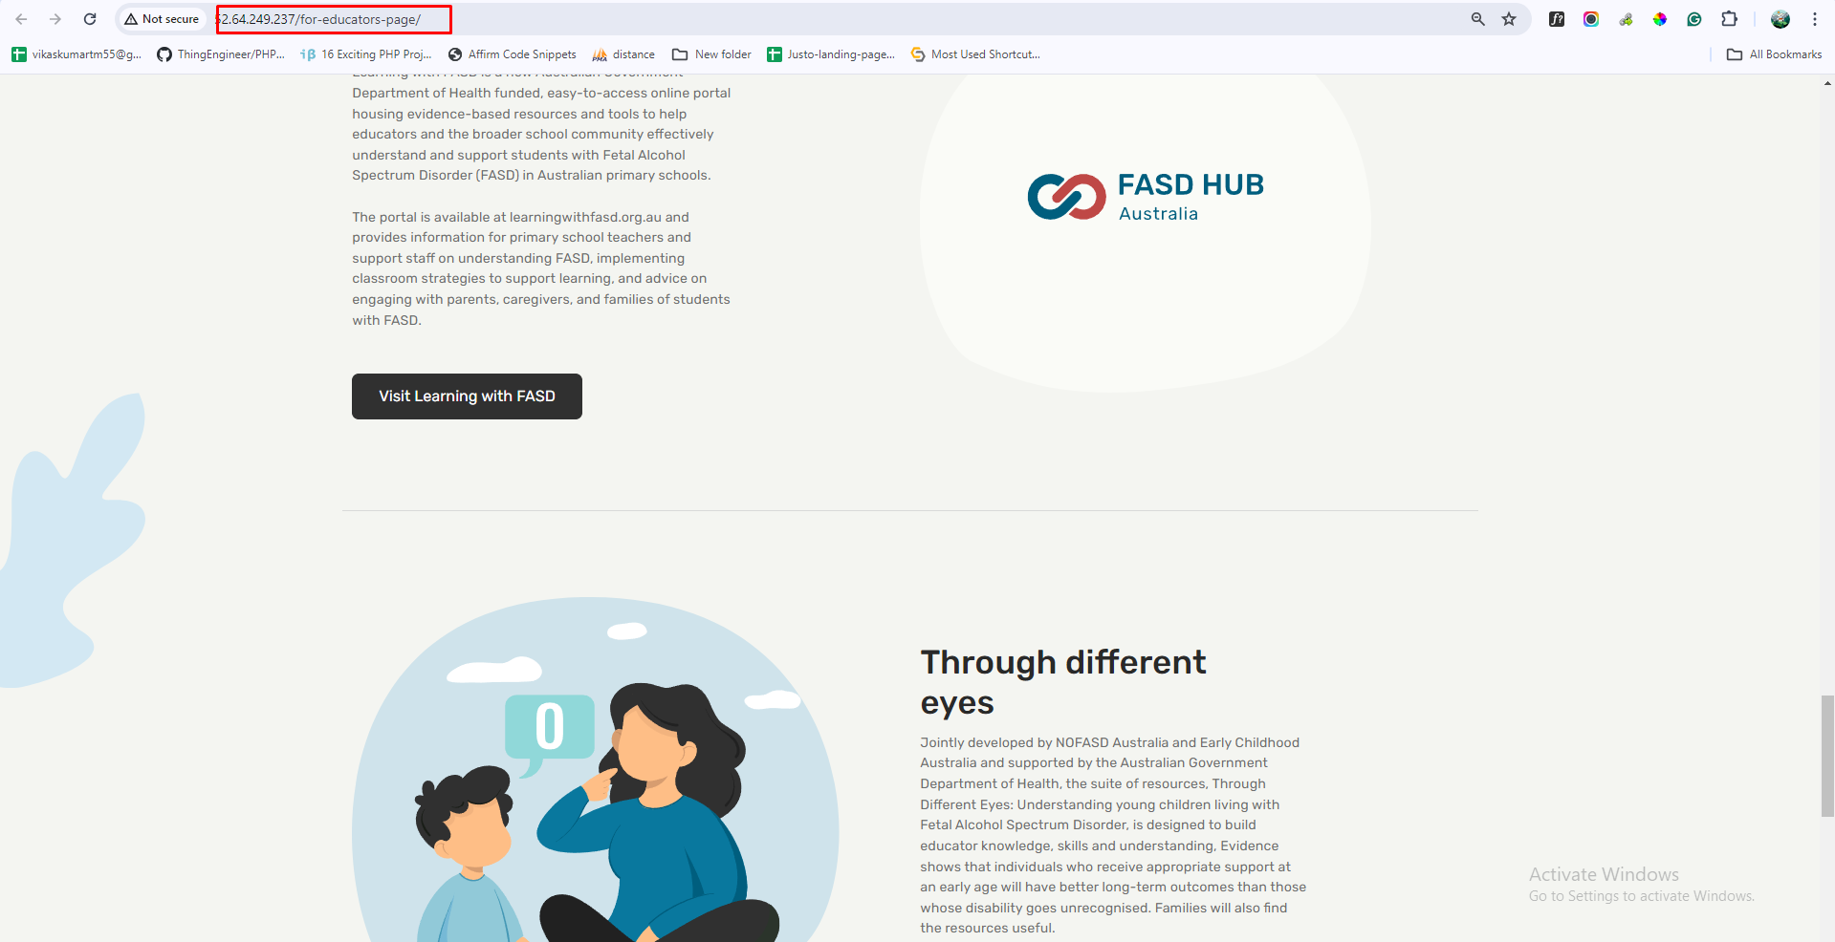

**CTA Section**

After this, we have to create a **CTA section**, and a preview of this section is attached below.

**Preview (CTA Section)**



**Steps below:**

First, click on **'Add row**,' then select **CTA Section** from the dropdown menu, as shown in the screenshot below.

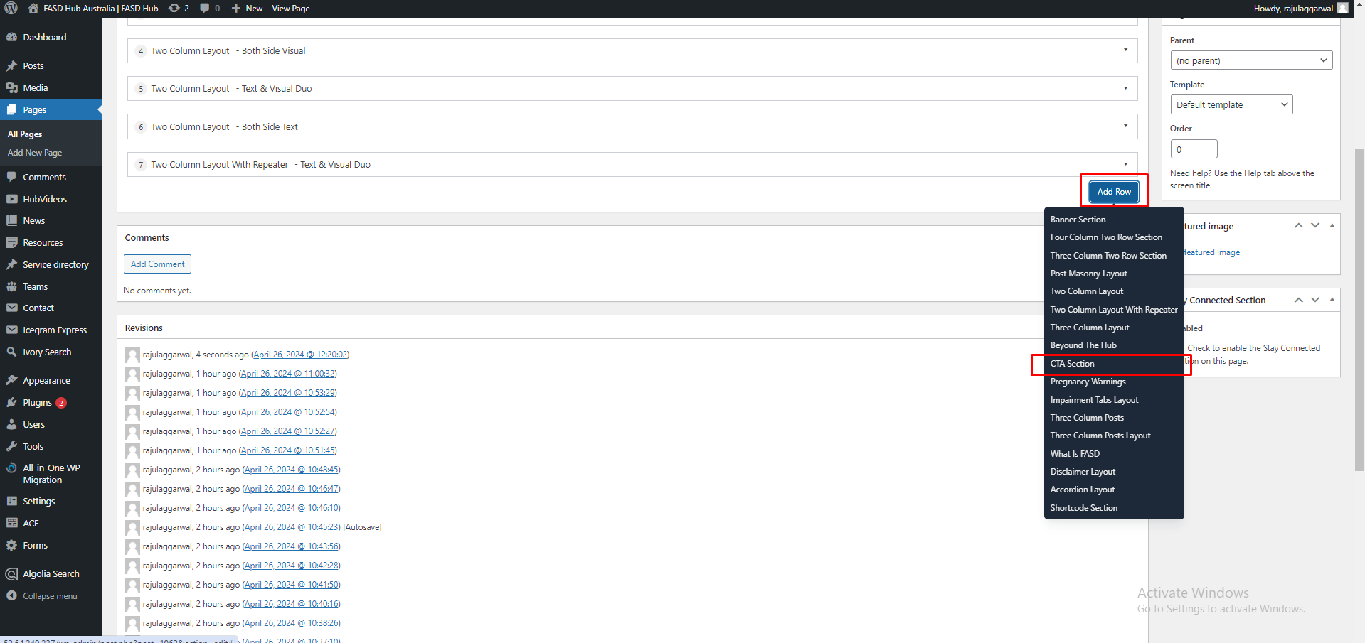

After that, the module related to the **CTA section** will be added, and you will find options related to this, such as **heading**, **description**, and **button**, as shown in the screenshot below.

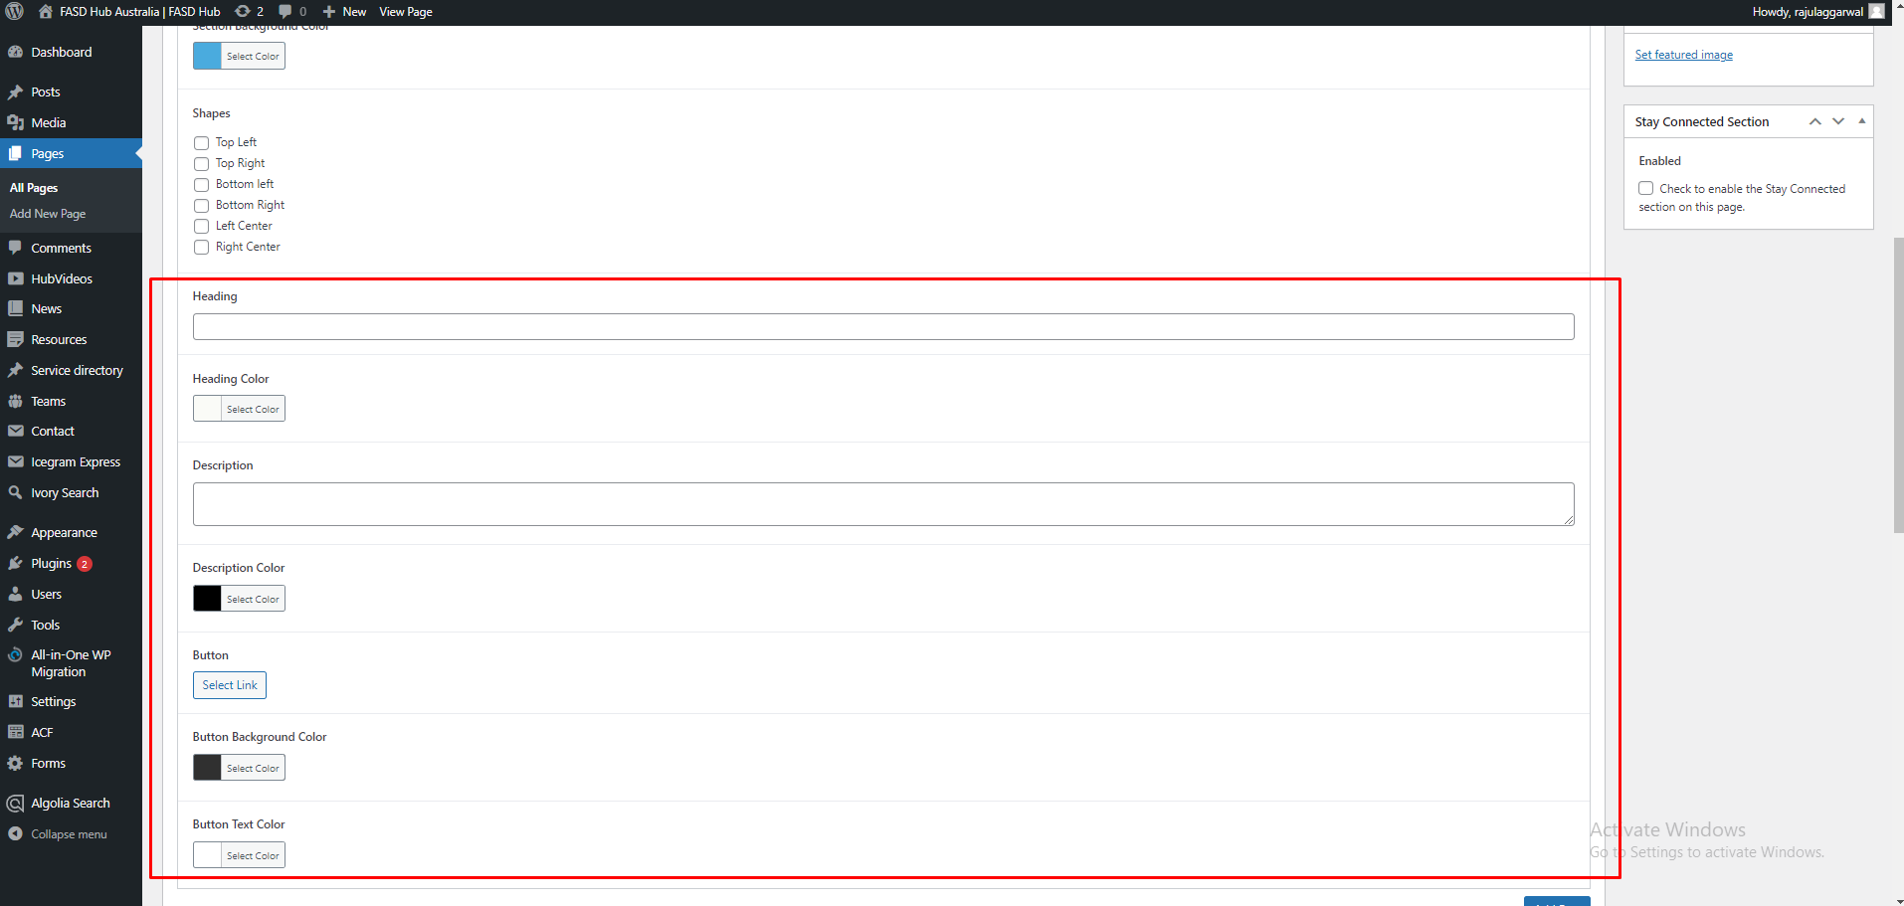

After adding content to these field boxes, save your changes and check your page, as shown in the screenshot below.

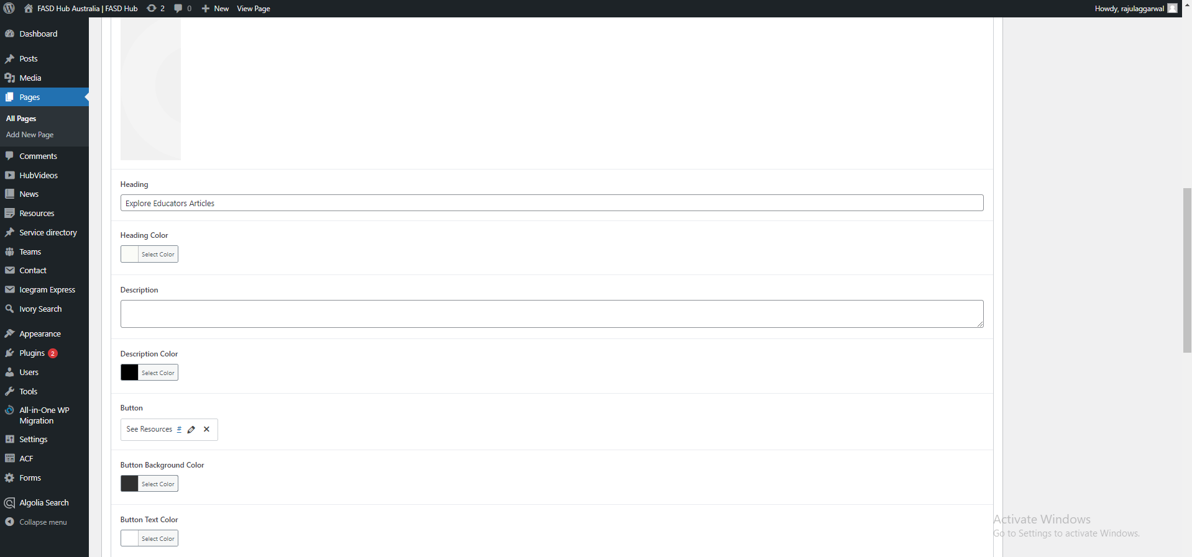

Finally, we have achieved the desired output of the **CTA Section** on the front end, as shown in the screenshot below.

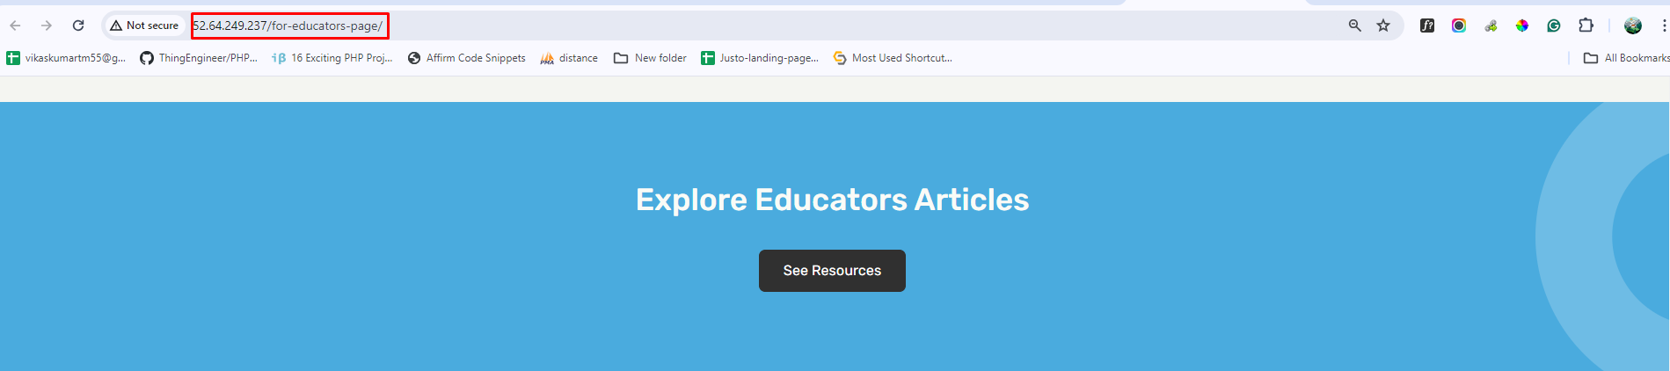

**Beyond the Hub**

After this, we have to create a **Beyond the Hub** section, and a preview of this section is attached below.

**Preview (Beyond the hub)**

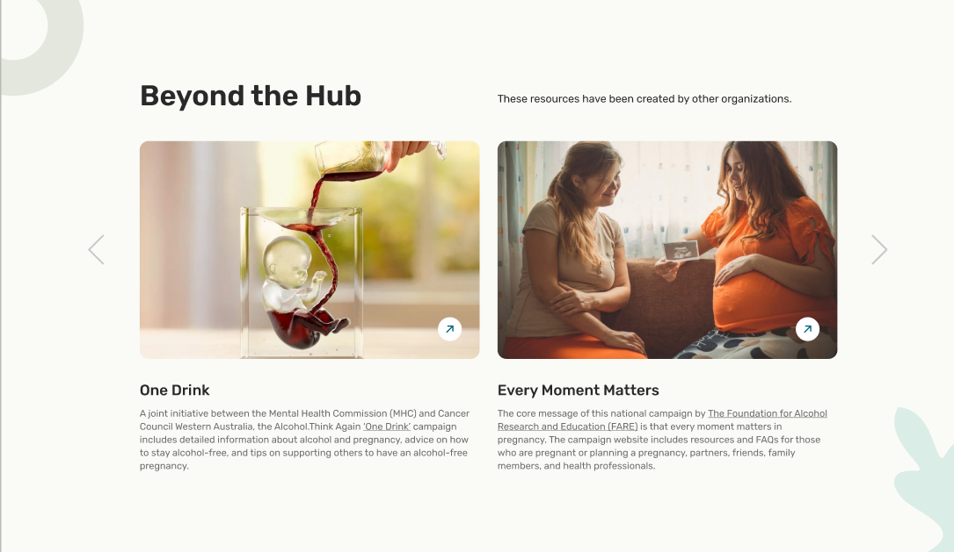

**Steps below:**

First, click on **'Add row**,' then select **'Beyond the Hub'** from the dropdown menu, as shown in the screenshot below.

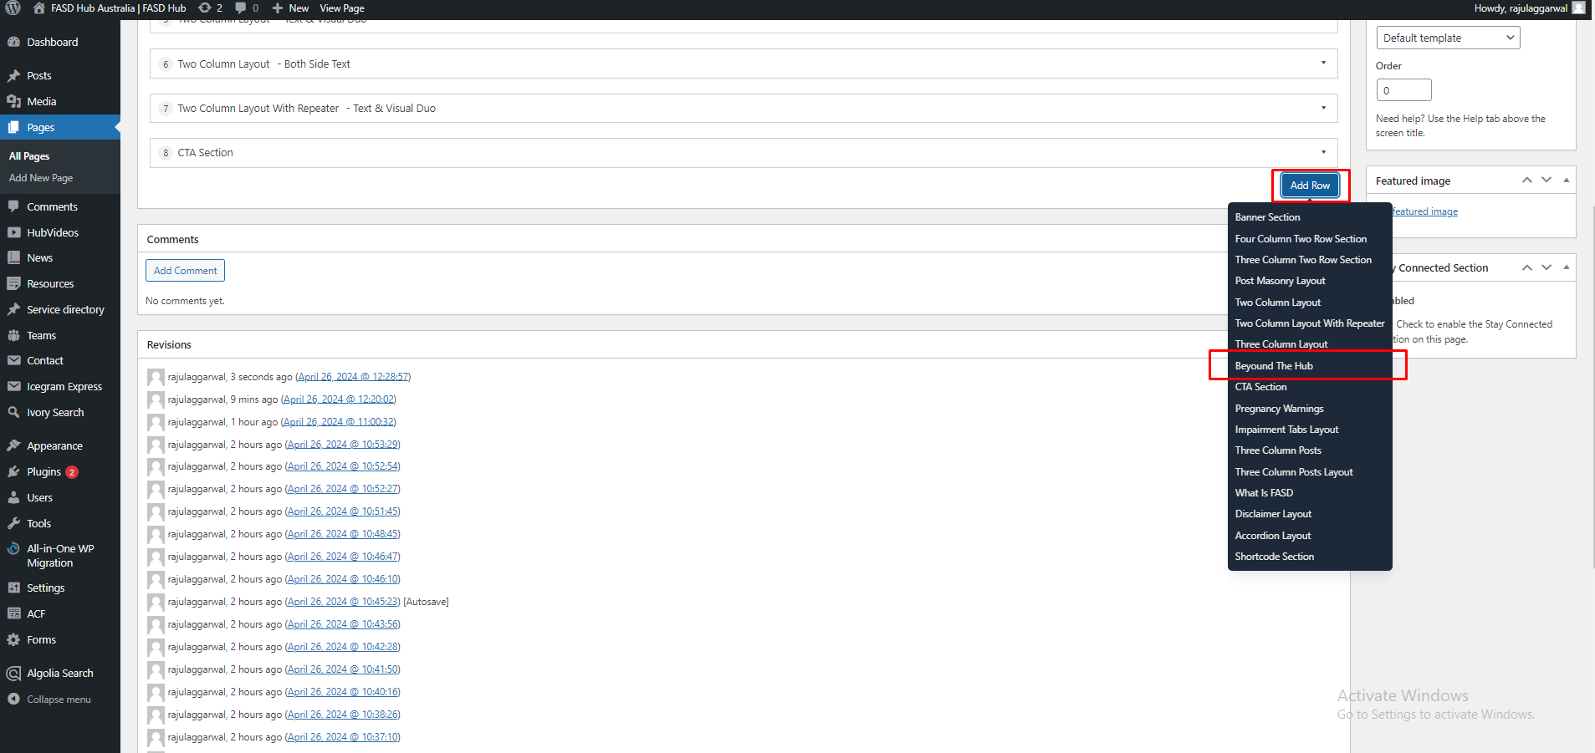

After that, the module related to **beyond the hub** will be added, and you will find options related to this, as shown in the screenshot below.

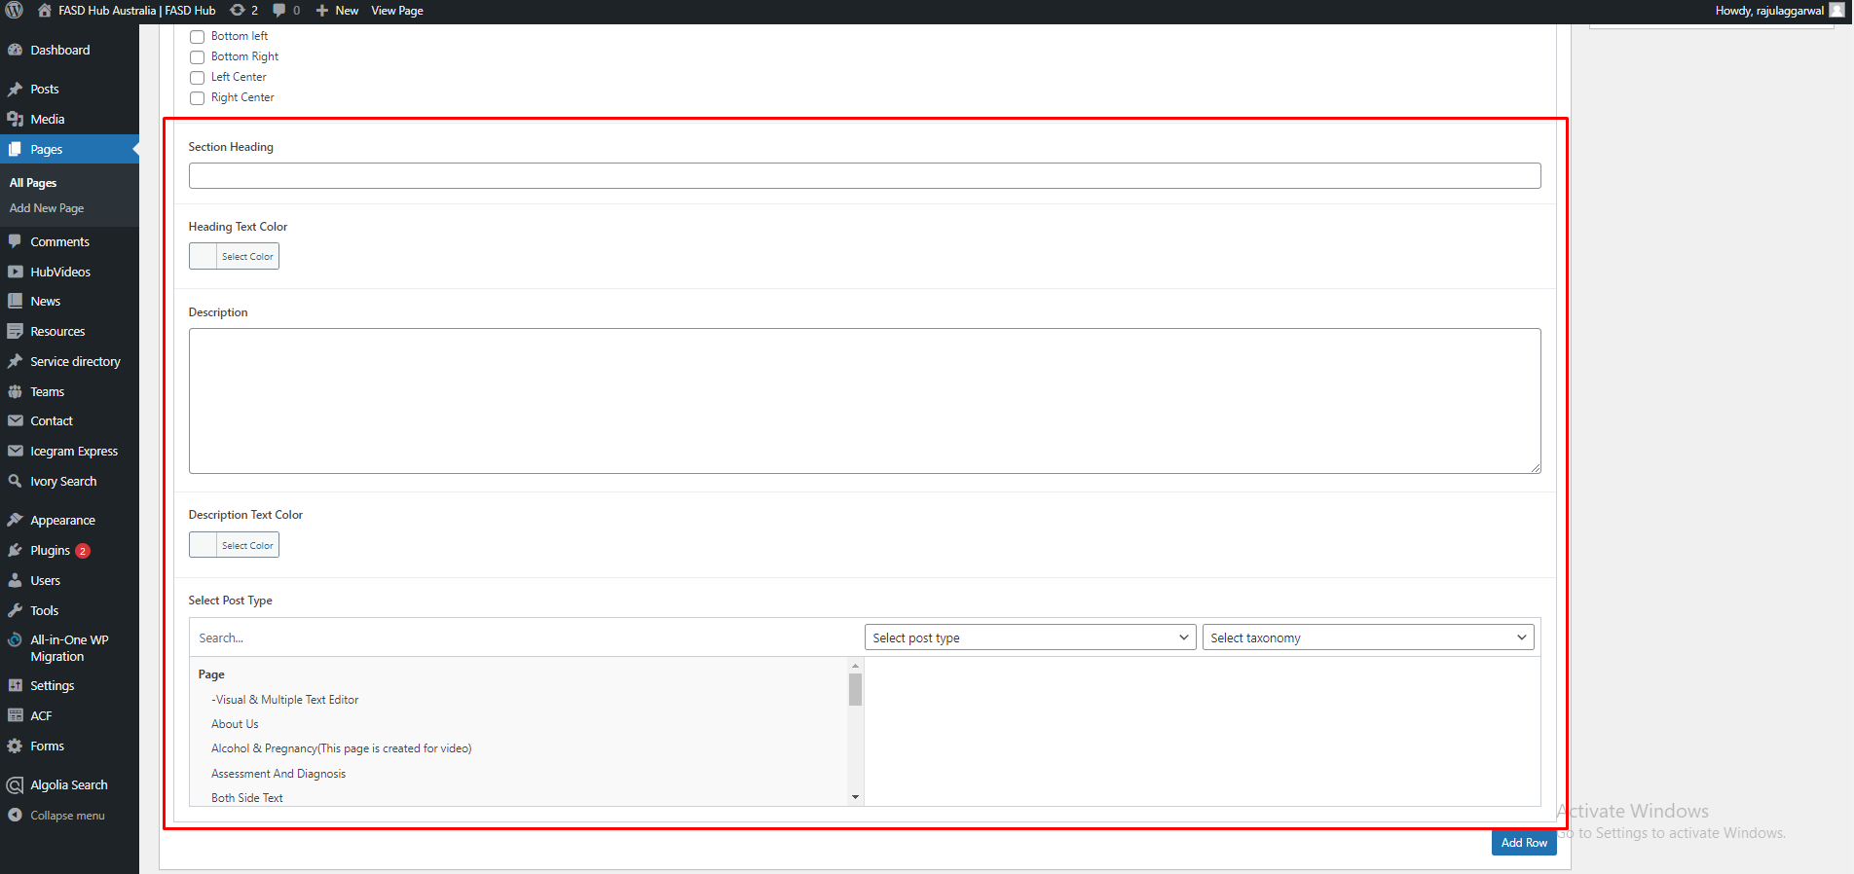

After filling in the section **heading** and **description**, you have to select the **post type** and **taxonomy** that you want. On the left side, you have to select the **post** of your desire that you want to display on the front end, as shown in the screenshot below.

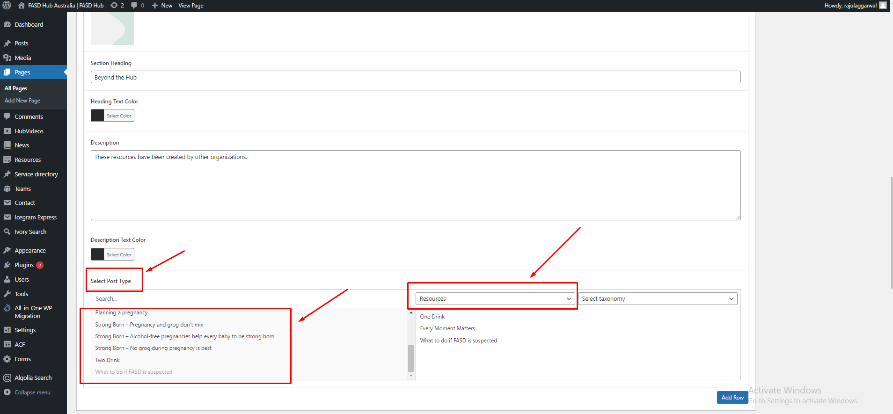

You can add multiple posts here, which will display as a slider on the front end, as shown in the screenshot below.

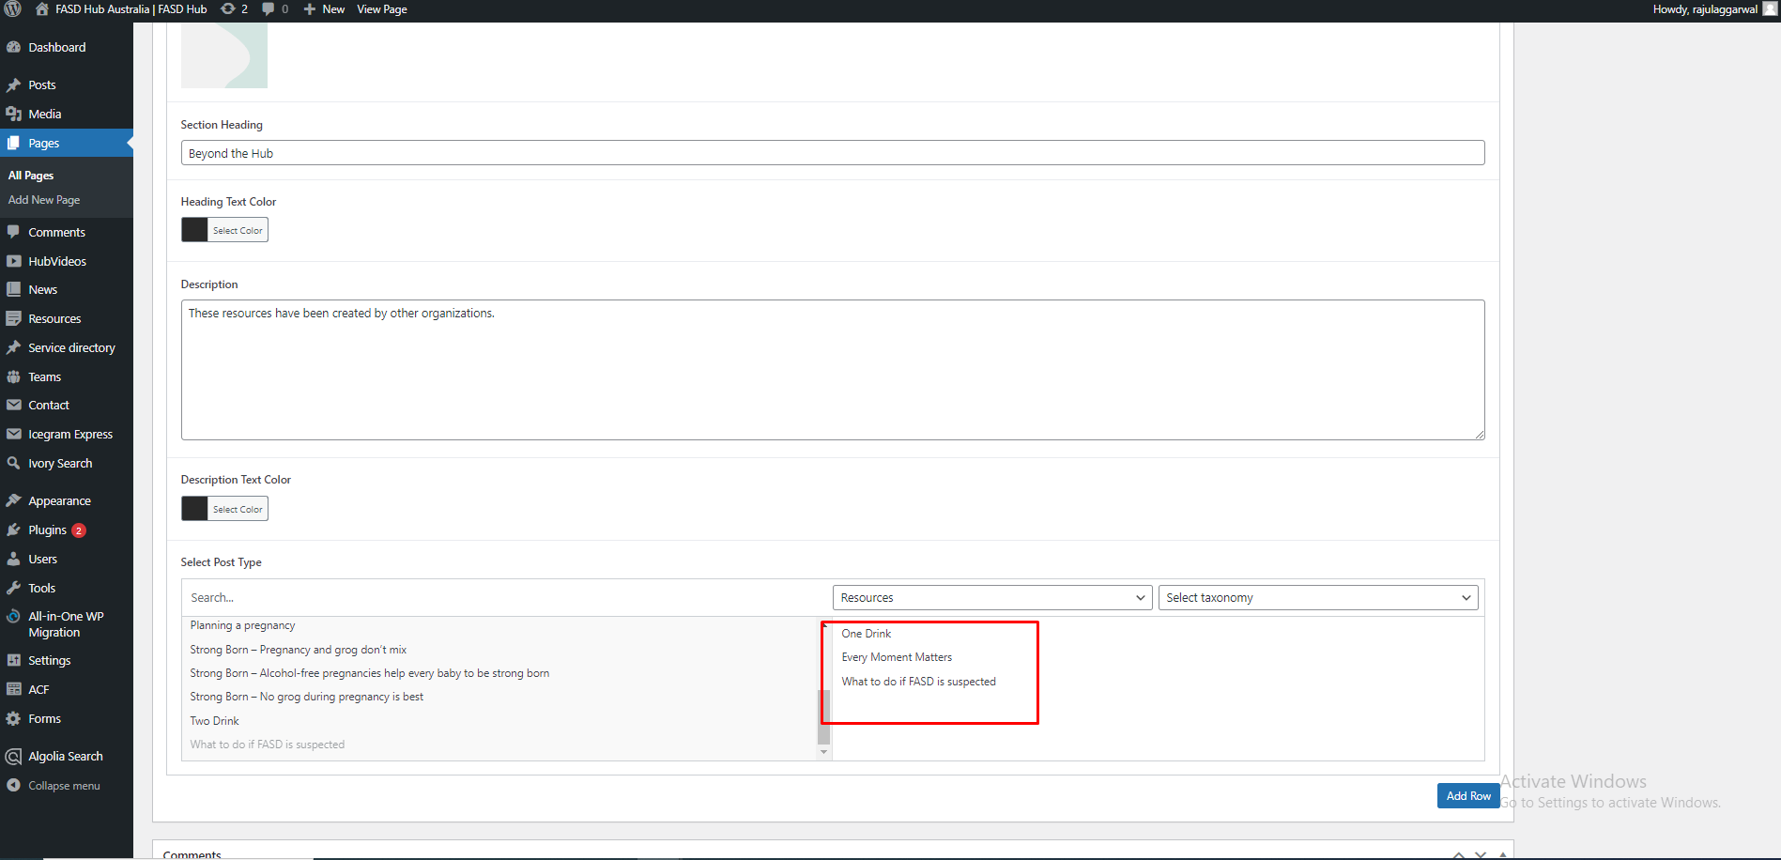

After adding content to these field boxes, save your changes and check your page, as shown in the screenshot below.

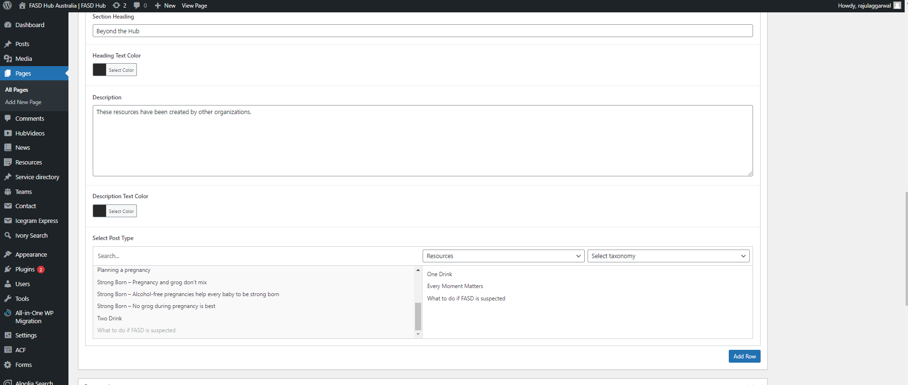

Finally, we have achieved the desired output of the **Beyond the Hub** section on the front end, as shown in the screenshot below.

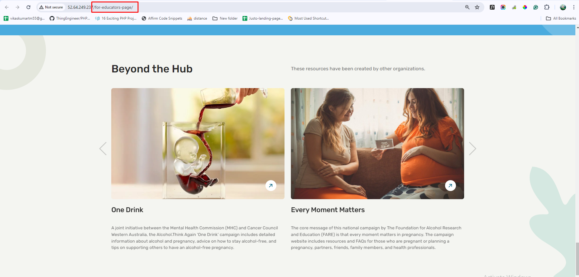

**Stay Connected Section**

At last, we have to create a **Stay Connected** form section, and a preview of this section is attached below.

**Preview (Stay Connected Section)**

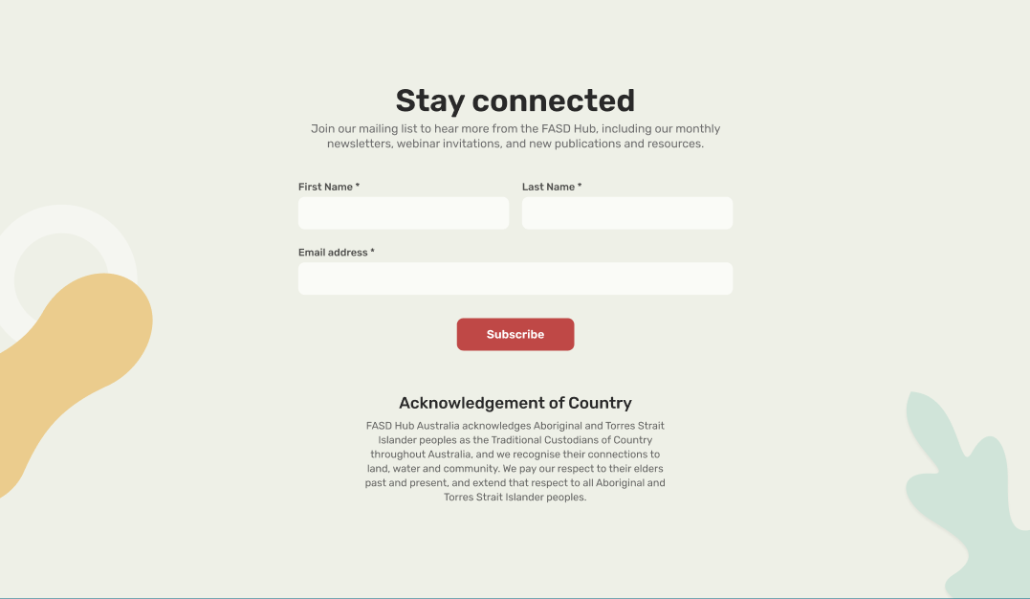

**Steps below:**

We've explained this section thoroughly in this document [**Manage Stay connected section | FASD**](https://docs.google.com/document/d/1Y0BL8USp3ZWQ0K7vJwSgke4kAlurEvEAzfnLTMls0Kw/edit). Could you please check it out? We'll provide an overview here for now.

On all pages, you will find an option with the name **Stay Connected Section** in the right sidebar of the page to enable or disable this section. From there, you can add or remove this section. Whenever you create a new page, this option will be checked by default, so it will be shown. If you want to hide it, you will need to uncheck it, as shown in the screenshot below.

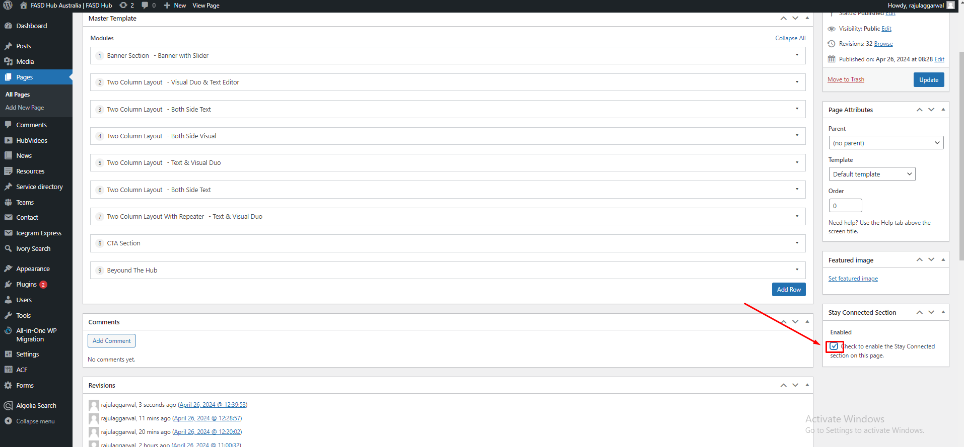

After checking the checkbox, save your changes by clicking the **Update** button on the right sidebar and check your page, as shown in the screenshot below.

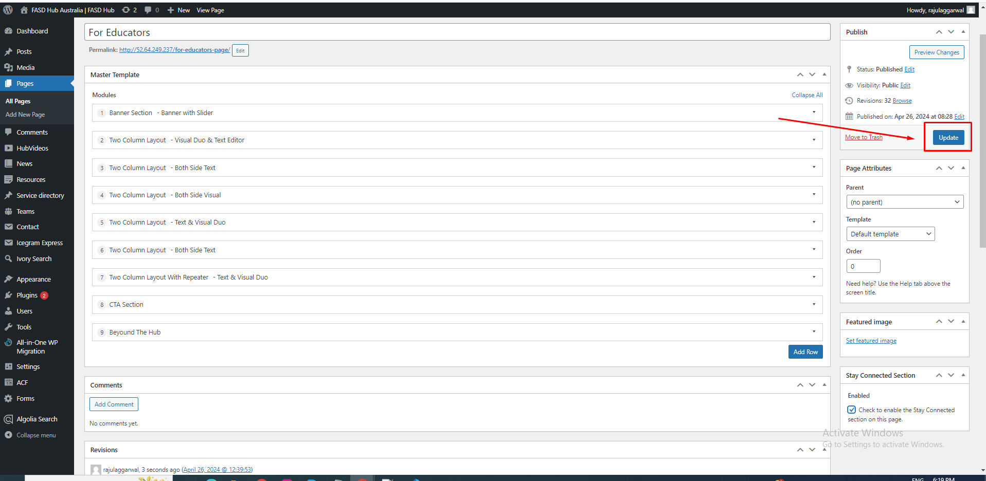

Finally, we have achieved the output of the **Stay Connected** section on the front end, as shown in the screenshot below.

